**Enterprise Messaging Infrastructure (eMI)**

**eMI-SOA System Design Document (SDD)**



Department of Veterans Affairs

August 2015

Version 5.1

When to Complete Each Section of the SDD

| Section | Completed On or Before PMAS Phase | Rationale |
| --- | --- | --- |
| 1 – Introduction | MS 0 Review; updated thereafter | Conceptual design should inform evaluation of investments |
| 2 - Background | MS 0 Review; updated thereafter | Conceptual design should inform evaluation of investments |
| 3 – Conceptual Design | MS 0 Review; updated thereafter | Conceptual design should inform evaluation of investments |
| 4 – System Architecture | MS 0 Review; updated thereafter | Conceptual design should inform evaluation of investments |
| 5 – Data Design | MS 1 Review; updated thereafter | Design details should be elaborated upon during PMAS Planning phase and prior to development |
| 6 – Detailed Design | MS 1 Review; updated thereafter | Design details should be elaborated upon during PMAS Planning phase and prior to development |
| 7 – External System Interface Design | MS 1 Review; updated thereafter | Design details should be elaborated upon during PMAS Planning phase and prior to development |
| 8 – Human Machine Interfaces | MS 1 Review; updated thereafter | Design details should be elaborated upon during PMAS Planning phase and prior to development |
| Attachments | MS 1 Review; updated thereafter | Design details should be elaborated upon during PMAS Planning phase and prior to development |

A product’s system design should be defined conceptually prior to the allocation of personnel and resources that occur at project initiation. This gives the enterprise an opportunity to evaluate IT investments before project teams are stood up and funding is allocated. Sections 1-4 that discuss the high-level design should be completed prior to MS 0. All sections should be completed and updated before MS 1. Projects will need to address all SDD approval constraints prior to the MS 2 review. In addition, the SDD should reflect the as-built product going into the MS 2 review.

Revision History

| Date | Version | Description/Comments | Author(s) |
| --- | --- | --- | --- |
| 09/28/2015 | 5.1 | * Added information on Section 7.2 (Interface Detailed Design) regarding DoD’s interfaces. Substituted two diagrams with a more accurate/updated one. * Added information in section 6.2.1.1.3 to reflect TRM-compliance and explicitly describe the Puppet Enterprise arrangement. * Added a diagram (Figure 9) and more descriptions of SOA tools in section 3.3. * Edited section 8.1 to reflect the SOI’s 508-compliance * Edited various segments for readability and aesthetics * Deleted a segment on archiving data (section 6.2.2.2.2) as the requirements were inaccurate. No archiving is required. | D. Yannakopoulos |
| 07/25/2015 | 5.0 | * Renamed the document as the “eMI SDD” * Updated vendors’ product names * Conformed content to newest SDD template * Updated several paragraphs for readability * Added VII Architecture and elements of external partners’ architectures | D. Yannakopoulos |
| 07/20/2015 | 4.0 | Complete updates with Government comments, to include the 2.2 release and all VIE activities to date | M. Waterloo |
| 05/06/2015 | 3.01.03 | Applied updates resulting from AERB review | C. Wilhite |
| 04/09/2015 | 3.01.02 | Applied updates resulting from AERB review | J. Wynn |
| 04/01/2015 | 3.01.01 | Updated to incorporated AERB pre-review comments | J. Wynn |
| 11/18/2014 | 3.01 | Annual review and update | C. Wilhite |
| 01/13/2014 | 3.00 | Signature page | P. Dick |
| 10/23/2013 | 2.03 | Release in support of Release 2.1.1 | P. Arrubla |
| 08/19/2013 | 2.02 | Release is support of Release 2.0 | L. Allen |
| 07/02/2013 | 2.01 | Release in support of Option 2 | L. Allen |
| 06/30/2013 | 2.00.01 | Change Page - updated APM information | L. Allen |
| 04/01/2013 | 2.00 | Signature page added to Section 12.0 | P. Dick |
| 02/19/2013 | 1.00 | Signature page added for Dr. Pearcy’s digital signature to accept this CDR document | P. Dick |
| 02/15/2013 | 1.01 | Update software version numbers | P. Dick |
| 02/01/2013 | 0.06 | Incorporate comments from the client/TMA | L. Allen  M. Charnoky |
| 01/09/2013 | 0.05 | Updates based on architectural discussions and input from CDR Dry Run | P. Klinker |
| 12/21/2012 | 0.04 | Enhance conceptual architecture section, update site deployment location numbers | C. Brown  P. Klinker |
| 06/26/2012 | 0.03 | Changes per customer questions/feedback. Additional updates to communications architecture, document formatting, rewrite for iEHR Platform Deployment, incorporation of peer review comments | P. Klinker |
| 06/18/2012 | 0.02 | Made minor grammatical changes and updated the TOC. | J. Wolf  J. Smith  N. Amiruddin |
| 06/06/2012 | 0.01 | Initial preparation and incorporation of peer review comments | J. Wolf  J. Smith  N. Amiruddin P. Klinker |

Table of Contents

1 Introduction 8

1.1 Scope 9

1.1.1 Definitions, Acronyms, and Abbreviations 10

1.1.2 References 12

1.2 User Profiles 13

2 Background 13

2.1 Overview of the System 14

2.1.1 The eMI SOA Infrastructure (SOI) 14

2.1.2 Communications with External Partners 15

2.1.3 Software Development Lifecycle (SDLC) and Environments 16

2.1.4 eMI Environments 17

2.2 Overview of the Business Process 18

2.2.1 Business Benefits 18

2.3 Overview of the Significant Requirements 22

3 Conceptual Design 23

3.1 Conceptual Application Design 23

3.1.1 Application Context 23

3.1.2 High-Level Application Design 23

3.1.3 Application Locations 25

3.2 Conceptual Data Design 26

3.2.1 Project Conceptual Data Model 26

3.2.2 Database Information 26

3.2.3 User Interface Data Mapping 26

3.3 Conceptual Infrastructure Design 27

3.3.1 System Criticality and High Availability 31

3.3.2 Special Technology 37

3.3.3 Technology Locations 37

3.3.4 Conceptual Infrastructure Diagram 37

4 System Architecture 41

4.1 Hardware Architecture 41

4.2 Software Architecture 43

4.2.1 Interfacing with External Partners 45

4.2.2 CPRS RDV and VistA Web 51

4.3 Network Architecture 51

4.4 Service Oriented Architecture / ESS 54

4.5 Enterprise Architecture 55

5 Data Design 57

5.1 DBMS Files 57

5.2 Non-DBMS Files 57

5.3 Data View 57

6 Detailed Design 57

6.1 Hardware Detailed Design 57

6.2 Software Detailed Design 62

6.2.1 Conceptual Design 62

6.2.2 Specific Requirements 78

6.3 Network Detailed Design 85

6.4 Security and Privacy 85

6.4.1 Security 85

6.4.2 Privacy 86

6.5 Service Oriented Architecture/ESS Detailed Design 87

7 External System Interface Design 87

7.1 Interface Architecture 87

7.1.1 Recommendations 87

7.2 Interface Detailed Design 89

8 Human-Machine Interface 91

8.1 Interface Design Rules 91

8.2 Inputs 91

8.3 Outputs 91

8.4 Navigation Hierarchy 91

8.4.1 Workspaces 92

8.4.2 Navigation 92

9 Attachment A – Approval Signatures 94

A.1. Identification of Technology and Standards 95

A.2. Constraining Policies, Directives, and Procedures 96

A.3. Requirements Traceability Matrix 96

A.4. Packaging and Installation 96

A.5. Design Metrics 96

List of Tables

Table 1 – Scope Inclusions 8

Table 2 – Scope Exclusion 8

Table 3 – Acronyms and Abbreviations 9

Table 4 – Reference Documents 12

Table 5 – SOA Suite Software Components 27

Table 6 (Grouping) – Technology Locations 37

Table 7. Description of Logical Segments 56

Table 8 – Existing AITC Systems 59

Table 9 – Future Regional Data Center Systems 60

Table 10 – Regional SOA Suite Products 62

Table 11 – COTS Product Versions 67

Table 12 – Ports and Protocols 70

Table 13 – Fail-Over Pattern 80

Table 14 – Security Requirements 84

Table 15 – Key eMI Security Controls 86

Table 16 – Key eMI Privacy Controls 86

Table 17. DES’ External Protocols (Inbound) 90

Table 18. DES External Protocols (Outbound) 90

Table 19. VII applicable standards 95

List of Figures

Figure 1 – ESB Role in the VA Enterprise 14

Figure 2- Service SDLC Document Process from The eMI Integration Guide 17

Figure 3 - Current state of VA-DoD interoperability 22

Figure 4 - DoD-VA Interoperability View: Full Operational Capability 23

Figure 5: High-level System Design 24

Figure 6 – High-Level Application Design 25

Figure 7 – Application Locations 26

Figure 8 – Conceptual Data Design 27

Figure 9 – SOI’s Primary Packages 28

Figure 10 – Physical Redundancy 35

Figure 11 – Clustering and Message Flow 37

Figure 12 – High-Level Notional Operational Concept for the SOA Suite with Sites and Enclave Boundaries 39

Figure 13: eMI VII environements 40

Figure 15 – Representative SOA Services 41

Figure 16 – RDC Design 43

Figure 17 – Multi-Instance Topology for SOA Suite 44

Figure 18 – High Availability Deployment Architecture 46

Figure 19. eHMP Architecture 48

Figure 20. DAS & VLER, System Architecture 49

Figure 21. CVIX and VistA Imaging Client – System Architecture; DoD images to VA 51

Figure 22. CVIX and VistA Imaging Client – System Architecture; VA images to DoD 51

Figure 23. CVIX and VistA Imaging Client – System Architecture; VA images to AWIV 52

Figure 24 – VA Network Interfaces 53

Figure 25 - VII Production Environment 54

Figure 26 - Transaction Details 55

Figure 27. eMI SOA components 56

Figure 28. Logical Architecture of eMI, Federated View 57

Figure 29 – Overall Regional Software Component Architecture 65

Figure 30 – Regional Clustering Approach 66

Figure 31 – SOA Suite System Flow 67

Figure 32 – Deployment Team Focus 70

Figure 33 – General Design for RDC Instance (Six VMs per Site) 82

Figure 34. DMIX/eMI Interfaces 90

Figure 35. WSRR Login Screen 93

Figure 36. Typical Business Space Interface 94

Figure 37. Business Space Widget Examples 95

# Introduction

The Department of Veterans Affairs (VA) and the Department of Defense (DoD) originally conducted an analysis to conclude that a commercial-off-the-shelf (COTS) Service Oriented Architecture (SOA) Suite with supporting services and sustainment would effectively manage the critical Enterprise Service Bus (ESB) functionality of the integrated Electronic Health Record (iEHR) enterprise. The purpose of the SOA Suite is to facilitate data sharing and application communication for iEHR implementation. The SOA Suite will provide the base capability from which the departments can leverage the broader exchange of information and support for iEHR initiatives within the design and integration of the SOA Suite ESB architecture.

The VA has determined the need for a high-performance, reliable solution that facilitates web service capabilities and secure communication between proprietary and open systems and applications. VA currently has a number of disparate systems supporting some of these functions. Complicating this architecture is the existence of hundreds of local sites that previously have not communicated using any type of pattern, nor conforming to today’s modern web service requirements for encryption and authentication, along with enterprise data centers that are based on loose architectures not following any standard set of patterns or guidance.

The service-oriented architecture presented herein, now formally known as the VA Enterprise Messaging Infrastructure (eMI), promotes a highly available, reliable, robust, and scalable infrastructure on which the VA can build a total architecture that will maximize current investments, while also promoting a path to a modern cloud framework. It provides the structure to hang security, reuse, mobility, and continuity of operations throughout the VA “cloud” and regionalization approaches currently underway. This allows VA programs the ability to maximize reuse of current APIs developed for legacy systems as modernized services that are encapsulated outside of eMI, and then transformed for service orientation through the eMI infrastructure.

eMI is composed of open source and COTS products that will allow secure and interoperable service integration with new and SOA-compliant legacy services to be integrated within the VA and DoD clinical information system domain. eMI will facilitate and expedite parallel deployment and transition of data driven interfaces by allowing disparate and distributed systems to be decoupled from proprietary applications. eMI consists of a full suite that contain the ability to execute business process and rules, utilize VA enterprise infrastructure for monitoring, easily integrate with identity access management (IAM) and certificate authority (CA) systems to provide a robust internal secured and encrypted trust and verification methodology, and internal mechanisms to automate log analysis and alerting to provide a preventative (as opposed to reactive) approach to system and process issues.

eMI will function as the communications backbone of the VA data sharing environment as well as the VA’s dedicated single-point transport mechanism for all connectivity services related to all interoperability integrations of medical health systems between the VA and other authorized federal agencies and private healthcare facilities. The first such Agency will be the DoD. As a complex switchboard and mediation device, it will underpin the technical operations of the enterprise to promote the seamless interdepartmental exchange of health services information.

VA and DoD have plans for modernization of their electronic health records (EHRs) over the next several years. In support of those long-term goals, the VA OI&T has identified an immediate need for integration of the eMI and Defense Medical Information Exchange (DMIX) data services that will improve the existing data sharing. The data sharing will reduce existing infrastructure redundancy to improve reliability of the connection, consolidate interfaces into one exchange viewer, and provide full access to the existing data exchange to all clinicians who need it. In addition to improving DoD/VA data sharing, these changes will also improve data sharing with the private sector providers who provide the majority of care for active duty service men and women, veterans and their dependents.

The purpose of this System Design Document (SDD) is to present the architecture and design of the COTS eMI in support of the VA Electronic Health Records (EHR) and associated internal or external information management systems. This SDD serves as a communication vehicle to capture necessary functionality changes through VA environments.

## Scope

The goal of this initiative is to acquire and implement a COTS system, including open source products and SOA-enabling capabilities. eMI will be used by VA to facilitate the delivery and use of services in support of the iEHR and associated information management systems.

This section outlines the scope inclusions and exclusions as illustrated in Table 1 and Table 2.

Table 1 – Scope Inclusions

| Includes |
| --- |
| Messaging interchange of various protocols including Health Level 7 (HL7 via the Captain James A. Lovell Health Care Center (JALFHCC) systems, and the Vitria Interface Engine (VIE) |
| Deployment of multiple messaging hub systems in six Regional Data Center (RDC) locations |
| Deployment of development and pre-production environments in the VA Austin Information Technology Center (AITC) and the Philadelphia Information Technology Center (PITC) |
| Messaging interchange between eMI and DMIX Data Exchange Service (previously known as BDA[1]-eMI interface) |

Table 2 – Scope Exclusion

| Excludes |
| --- |
| Hardware deployment is not within the scope of SOA Suite. |
| The SOA Suite will enforce security policies but not define or dictate them. |
| Network infrastructure is provided as government furnished equipment (GFE), owned and maintained by the government, and used to host the SOA Suite. |
| Data Centers: physical locations to host required hardware and networking components that are required to support the SOA Suite, including reliable power and appropriate security and environmental controls. |
| Infrastructure Platforms: hardware to support the SOA Suite (processors, memory, and storage) must be in place to deploy the solution. |
| Most disaster recovery aspects are dependent upon the network and hardware provider (e.g., backups, hardware redundancy, etc.). |

### Definitions, Acronyms, and Abbreviations

Table 3 – Acronyms and Abbreviations

| Acronym | Description |
| --- | --- |
| AITC | Austin Information Technology Center |
| APM | Application Performance Management |
| ATO | Authorization to Operate |
| BDA | BHIE DoD Adaptor |
| BHIE | Bi-Directional Health Information Exchange |
| BPEL | Business Process Execution Language |
| BPM | Business Process Manager |
| C&A | Certification & Accreditation |
| CIM | Common Information Model |
| CM | Configuration Management |
| COTS | Commercial Off the Shelf |
| DES | DMIX Exchange Service (formerly BHIE DoD Adaptor; BDA) |
| DMGR | Deployment Manager |
| DMIX | Defense Medical Information Exchange |
| DNS | Domain Name System |
| DoD | Department of Defense |
| DTE | Development Test Environment |
| EHR | Electronic Health Records |
| eMI | Enterprise Messaging Infrastructure |
| EO | Enterprise Operations |
| ePHI | electronic Protected Health Information |
| ESB | Electronic Service Bus |
| GFE | Government Furnished Equipment |
| HCP | Healthcare Connectivity Pack |
| HL7 | Health Level 7 |
| HTTP | Hypertext Transfer Protocol |
| HTTP Server | Hypertext Transfer Protocol Server |
| HTTPS | Hypertext Transfer Protocol Secure |
| IA | Information Assurance |
| IaaS | Infrastructure as a Service |
| IAM | Identity and Access Management |
| ICD | Interface Control Document |
| iEHR | integrated Electronic Health Record |
| IP | Internet Protocol |
| ISO | Information Security Officer |
| JALFHCC | Captain James A. Lovell Health Care Center |
| LDAP | Lightweight Directory Access Protocol |
| LDSI | Laboratory Data Sharing and Interoperability |
| MLB | Melbourne, Florida |
| MLLP | Minimum Lower Layer Protocol |
| MOM | Master of Masters |
| MQ | Message Queue |
| N/A | Not Applicable |
| NAS | Network Attached Storage |
| NFS | Network File Server |
| OS | Operating System |
| OVA | Open Virtualization Appliance |
| PHI | Protected Health Information |
| PII | Personally Identifiable Information |
| PITC | Philadelphia Information Technology Center |
| PMAS | Program Management Accountability System |
| PWS | Performance Work Statement |
| RDC | Regional Data Center |
| RHEL | Red Hat Enterprise Linux |
| RTM | Requirements Traceability Matrix |
| SAML | Security Assertion Markup Language |
| SAN | Storage Area Network |
| SDD | System Design Document |
| SDK | Software Development Kit |
| SEDR | System Engineering and Design Review |
| SFTP | Secure File Transfer Protocol |
| SID | Standard Item Deliverable |
| SLA | Service Level Agreement |
| SOA | Service Oriented Architecture |
| SSG | Secure Span Gateway |
| STIG | Security Technical Implementation Guide |
| TRM | Technical Reference Model |
| URL | Uniform Resource Locator |
| VA | Department of Veterans Affairs |
| vCPU | Virtual Central Processing Unit |
| VIE | Vitria Interface Engine |
| VII | VA/DoD Interoperability Integration |
| VistA | Veterans Health Information Systems and Technology Architecture |
| VLER | Virtual Lifetime Electronic Record |
| VM | Virtual Machine |
| WAS | WebSphere Application Server |
| WBM | WebSphere Business Monitor |
| WMB | WebSphere Message Broker |
| WMQ | WebSphere Message Queue |
| WODM | WebSphere Operational Decision Management |
| WPS | WebSphere Process Server |
| WSRR | WebSphere Service Registry and Repository |
| WTX | WebSphere Transformation Extender |
| XACML | Extensible Access Control Markup Language |
| XML | Extensible Markup Language |

### References

Table 4, below, shows the documents that are referenced within this SDD.

Table 4 – Reference Documents

| Document Control Number | Document Name/Description |
| --- | --- |
| iPLRD | Inter-Agency Program Level requirements document, IPLRD v0_91 10102012 (version 0.9i), August 2012 |
| PWS | Performance Work Statement (PWS), VA1118-11-D-1009, July 2014 |
| SID 014 | SOA Suite Contingency Operations Plan |
| SID 031 | SOA Suite Requirements Traceability Matrix (RTM) |
| SID 032 | Systems Requirements Specification/Business Requirements Document, January 2014 |
| SID 048 | SOA Suite ICD |
| SID 049 | Version Description Document, January 2015 |
| SV-4 | Systems View Functional Model |

## User Profiles

eMI is a software middleware product that is largely transparent to the end user community while providing message connectivity between disparate systems that are utilized in their daily activities.

The eMI approach will support interoperable computing services that, inside the VA represent, but are not limited to, common health record applications and services such as Pharmacy, Disability Evaluation, Dental Care, and Laboratory. It will continue to provide services from selected legacy systems until they are transitioned into the new system.

In addition, eMI will also support interoperable computing services with authorized agencies outside the VA IT environments such as DoD, Dept. of Treasury, and University Healthcare Facilities such as the Louisiana State University Health Sciences Center.

Since eMI is, in actuality, a host of SOA-based applications, it does not have users other than the technical personnel responsible for the operations of the SOA-hosting infrastructure and the integration technical teams that will assist the development teams of the SOA-based applications to integrate their applications’ functionality into eMI[2].

# Background

To provide foundational capabilities, the iEHR program will lay the groundwork for the enterprise and will deliver a limited set of capabilities to stakeholders for their evaluation and use. The program will support the evaluation, selection, development, testing, and staging of iEHR architectural elements, messaging standards, SOA-based services, components, databases, and applications that will be used to provide iEHR system capabilities.

Additionally, the iEHR program will evaluate system capabilities in the development/delivery pipeline for VA’s Veterans Health Information Systems and Technology Architecture (VistA) programs for integration into the iEHR architecture framework and possible limited deployment.

## Overview of the System

### The eMI SOA Infrastructure (SOI)

eMI will be deployed to VA’s AITC, PITC, and six RDCs. eMI will include an ESB messaging engine supported by a security gateway and sophisticated routing services. The role of eMI in the VA enterprise will be to mediate and service data transactions in support of modernized and legacy VA applications. Stakeholders include joint clinical capabilities. Clinicians and other end users do not directly interact with eMI, but rather with systems connected to eMI.

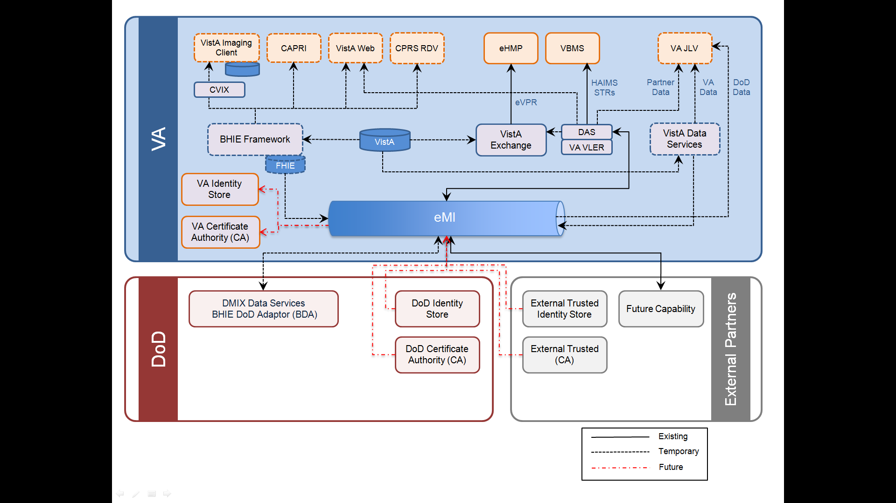

Figure 1 – ESB Role in the VA Enterprise[3]

As shown in Figure 1, eMI works with common interface standards, common data centers, and the Common Information Interoperability Framework to move data in a standard and reusable way in support of VA applications and user interfaces.

This approach facilities a single interface for all exchanges of information in a secured, encrypted message that will allow for data non-repudiation and prevent outside hijacks and malicious code insertion. It also lessens the number of interfaces required to make Records of Source (ROS) available to any consumer in and outside the Enterprise.

### Communications with External Partners

eMI drives the VA toward a modern web service approach for sharing information, both internal and external to the VA. As producers of information, services can be exposed to other agencies through gateways, where identity and trust can be verified to help build a trusted and encrypted transaction.

Groups external to VA, such as the DoD, the Dept. of Treasury, or authorized University medical centers, can either use accepted trust and identity standards mapped out with development teams, or the development teams can enforce data exposure via web portals using VA credentials obtained through a VA accreditation source. This extends a flexibility never before seen in VA transactions, and then allows VA to fully examine and audit data use and access to maintain better both security and portfolio management. This is the same comprehensive approach used by modern organizations in the financial, health, customer relations management, and enterprise resource planning systems in the civilian sector.

Furthermore, by combining this approach with FISMA and FIPS standard security, the VA ensures not only a better investment in IT development but secure transactions as well. Traffic coming into the VA via the eMI infrastructure is trusted

* to be from the source expected to be requesting the data,
* not to inject any invalid data or malicious code, and
* to provide an auditable user and role associated with each transaction that will be used to check both transactional integrity as well as monitor HIPAA and HITECH compliance.

The first external partner with which the VA will interact is the DoD. There exist many VA/DoD Health Interoperability Programs. However, the following are the primary ones with which eMI will interact.

* Federal Health Information Exchange (FHIE)
* Bidirectional Health Information Exchange (BHIE)
  + BHIE AHLTA, BHIE SHARE, BIA, DocSearchXCA, MPI
* DMIX Exchange Service (DES), formerly BHIE DoD Adaptor (BDA)
* Joint Legacy Viewer (JLV)
* VistA Exchange (Vx)
* Enterprise Health Management Platform (eHMP)
* CHDR (CDR/HDR)

eMI’s VA*/*DoD Interoperability Integration (VII) project provides for the migration and integration of the existing P2P interoperability interfaces (VLER and BHIE) to the VA Enterprise Messaging Infrastructure (eMI). eMI VII also transitions the connectivity between the VA, DoD, and other external agencies architecture for use of the VA eMI. This effort also supports DoD and VA’s intent to move data within the BHIE repository into stores within the DoD enclaves and DMIX in support of VA’s efforts to get and provide all data through VistA Exchange and ultimately retire BHIE and other legacy information sharing mechanisms. VII’s scope will be initially (Phase I) limited to:

* The migration and integration of the existing P2P interoperability interfaces (e.g., Virtual Lifetime Electronic Record (VLER) Health eHealth Exchange software, Bi-Directional Health Exchange (BHIE)) to the VA enterprise Messaging Infrastructure (eMI), and
* The transition of the data connectivity between the VA, DoD to use of the VA eMI.

### Software Development Lifecycle (SDLC) and Environments

eMI is designed with full development and operations in mind. Incorporating a business process on to eMI is a natural consequence of developing a business need using REST/SOAP/JMS web services as a part of the SDLC. It does not require additional documentation or any deviation from PMAS and ProPath processes.

Figure 2, below, depicts the natural order of documents typically produced in the SDLC. The diagram shows the addition of governance processes that help guide and enhance development of business process. These governance steps are described on the ESS website, and currently involve two bodies: *ESS Center of Excellence* and the *eMI IT*. The process can be found at [ESS-SOA](http://vaww.ea.oit.va.gov/enterprise-shared-services-service-oriented-architecture/)

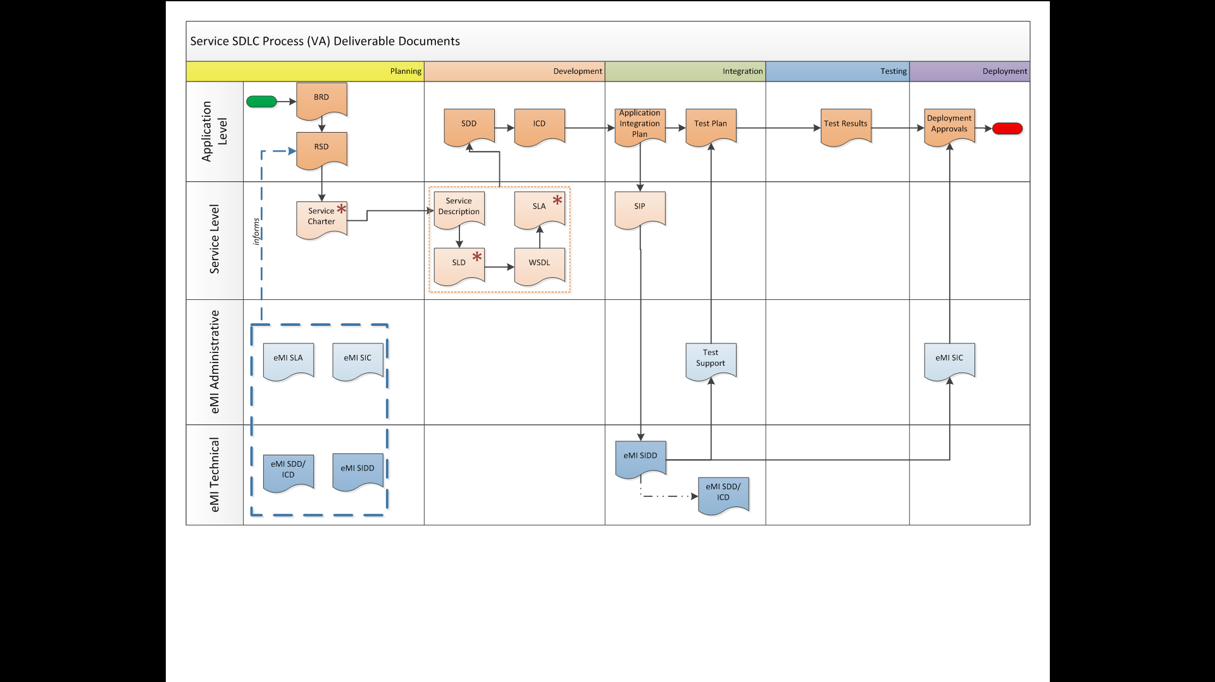

Figure 2- Service SDLC Document Process from [The eMI Integration Guide](http://vaww.oed.portal.va.gov/pm/iehr/vista_evolution/SOA/Project%20Documents/Service_Integration_Process.pptx)[4]

The eMI Integration process is described in detail in the eMI Integration Guide. This document is designed to support incoming teams. It is written in plain, non-technical language, and discusses the requirements and actions at every step of the process. In combination with VA PM and engineering support, this guide will help the business and functional communities understand and better navigate how to assist IT in building solutions that best meet their business needs, with a focus on reuse and end user metrics and satisfaction.

#### ****eMI Customer Intake Process****

The [eMI wiki](http://vaww.oed.portal.va.gov/communities/VAeMI/eMI%20WIKI/eMI%20IT.aspx) describes in detail how teams can submit SOA-based services for inclusion into the eMI SOI.

* Every customer who needs to use eMI should sign an SLA. Please complete the [eMI SLA Document](http://vaww.oed.portal.va.gov/communities/VAeMI/eMI%20Documents/New%20Customer/eMI_SLA_Template_v1%209_2.DOCX) and email it back to the eMI team at [VAeMIinfo@va.gov](mailto:vaemiinfo@va.gov?subject=SLA%20Document).
* For every Service a [Charter](http://vaww.ea.oit.va.gov/wp-content/uploads/2014/03/service_charter_template_draft1.docx) needs to be created that describes at a high level description of the service is and does.
* All Services need to be registered in the IBM WebSphere Registry and Repository (WSRR).

#### ****Service Governance in WSRR****

WSRR is an enabler of service governance. It serves as the authoritative source for SOA services and artifacts throughout the life cycle, from model to assemble, deploy, manage, and eventually retirement. WSRR is optimized for the runtime environment to enable dynamic endpoint selection and retrieval policies and to ensure that the proper subscriptions are in place to invoke a service. **The documents** [Registering a Service in WSSR](http://vaww.oed.portal.va.gov/communities/VAeMI/eMI%20Documents/Registering%20a%20Service%20in%20WSSR.pdf) and [WSSR User Guide](http://vaww.oed.portal.va.gov/communities/VAeMI/eMI%20Documents/WSRR%20User%20Guide-%20eMI%20GEP.docx) offer an overview of registering services and information that will help users navigate WSRR and perform basic tasks respectively.

Once a service has been defined, implemented, the Service Developer must fill out the [***Service Documentation Form***](http://vaww.oed.portal.va.gov/communities/VAeMI/eMI%20Documents/New%20Customer/eMI%20Service%20Documentation%20Form-Template-04082015.docx)and email it back to the eMI team at [VA-eMI-Service-Registration-Team@va.gov](mailto:VA-eMI-Service-Registration-Team@va.gov). The [***WSRR Metadata and Classification Reference***](http://vaww.oed.portal.va.gov/communities/VAeMI/eMI%20Documents/New%20Customer/eMI%20WSSR%20Metadata%20and%20Classifications%20Reference%20-%20Nov%2024%202014.xlsx) document offers additional service metadata information.

### eMI Environments

To support a proper development and operations posture, eMI was designed in the AITC to help teams build software in staged environments that best align with the key activities in an agile process. There are four major environments in eMI:

#### Development

A lightweight environment that allows developing teams to interact on the dev/test environment (DTE) side of the VA networks. It consists of a single stack of each COTS product. It is loosely configuration managed to maintain eMI integrity, but focused on development teams delivering web services to build capabilities

#### Integration and Test

A large clustered environment meant to simulate production. The DTE environment is serving as the integration and testing environment. It is tightly CM-controlled. Within this environment ATO scans, test, and other government functions for delivered software occur.

#### Pre-Production

This is a full stack single instance environment. It is considered as *production* regarding the network. Only approved software can be installed here. Applications must have ATO and VA process approval toward IOC to be included in this environment. The environment provides production type UAT and performance testing as well as an environment to examine break/fix and troubleshoot issues.

#### Production

This is the live VA environment. It includes fully production networks and it is fully secured.

## Overview of the Business Process

To provide foundational capabilities, the iEHR program will lay the groundwork for the enterprise and will support the evaluation, selection, development, testing, and staging of iEHR architecture elements, messaging standards, services, components, databases, and applications that will be used to provide iEHR system capabilities. The goal is to demonstrate the advantages of a single interface to access and to view health information.

### Business Benefits

#### eMI SOA Environment

The following is a brief overview of Business User Stories detailed in the SID 03.2 System Requirements Specification/Business Requirements Document.

* Manage standards-based data messaging to enable iEHR sharing and flexibility between the DoD and VA networks
* The functionality to monitor performance-related metrics and have reporting capability so users are informed of the SOA Suite compliance with Service Level Agreements (SLAs)
* Publish Web services into a service registry so that a (potential) service consumer can search the service registry to discover services offering the functionality needed. The consumer then can send a service request to the service provider
* Provide tools that support common messaging standards and HL7 data transformation to maintain interoperability and business needs flexibility within VA systems at regional and local levels
* Enforce access control with policy enforcements and auditing and provide user identity management and non-repudiation, including secure data communication using Public Key Infrastructure encryption and the Web-based Hypertext Transfer Protocol Secure (HTTPS) transmission protocol
* Provide a service registry to ensure that service providers and service consumers adhere to SOA governance processes, which are woven throughout the life cycle management approach of services
* Capture and modify business rules for processing services so users do not have to modify underlying software code

#### Integration with DoD

The **Interoperability Enterprise Transition Plan** (akaBHIE Transition Plan), is a multi-step, multi-year transition from existing interoperability infrastructure to the target infrastructure and systems of DoD and VA. The plan incorporates three important things:

* The hard work by hundreds of people who have analyzed, research, designed, engineered, and sustained the existing systems
* The strengths and tremendous groundbreaking value of the existing systems
* A new direction, stemming from the past successes of BHIE, while looking to the future

eMI will offer the VA’s interoperability infrastructure of medical health systems and it will provide full access to the existing data exchange to all VA and DoD clinicians who need it, materializing the following benefits in the process:

* Realize the data sharing needs of the two Departments: Historical, legal, and moral imperatives within (and above) the Departments have led to a large number of data sharing initiatives that have accumulated over the years
* Fulfill the respective EHR commitments: Both Departments have extremely large commitments towards modernizing their EHRs
* Continue building on existing work and experience to eliminate redundancy of functionality: Both Departments have already deployed data services as part of these modernization efforts that address new requirements and render the pre-existing systems redundant
* Offer a cost-saving solution: Budget and operational constraints do not allow continuance of duplicative systems

The current state of the DoD-VA Interoperability is shown in Figure 3, below. It depicts the following IT systems on the VA side of the diagram.

* eMI: A self-contained, one-point channel that manages all data exchanges between VA and DoD. Its core strengths are the underpinning SOA technical framework
* VA VLER: **Virtual Lifetime Electronic Record** gives authorized VA and non-VA health care providers secure access to certain parts of patients’ electronic health record
* DAS: VLER Core’s product, **Data Access Service**, is the VA EA required data exchange broker between VA and external partners
* VistA: An enterprise-wide information medical system built around an Electronic Health Record (EHR). It consists of nearly 160 integrated software modules for clinical care, financial functions, and infrastructure
* VA JLV: **Joint Legacy Viewer** is a GUI that provides a common data view of real-time data from both DoD and VA electronic health record (EHR) information systems and data sources are collated and displayed chronologically on a single screen.
* VBMS: **Veterans Benefits Management System** is web-based paperless benefits claims processing system
* VistA Data Services: Central service for obtaining VA health data from all 130+ VistA instances. Will be used by the DoD intends to converge all viewing of VA data capabilities into a single viewer. (initially; expectation is to convert to VistA Exchange when ready)
* VistA Exchange: Middleware (aggregation system) that provides the Enterprise Virtual Patient Record (eVPR), allowing for delivery of a single, common health record to be utilized throughout the continuum of care.
* eHMP: A clinician-facing application showing longitudinal patient information in a single clinical view. It integrates several functionalities into the VA/DoD interoperability infrastructure to support VistA Evolution
* BHIE Framework: **Bidirectional Health Information Exchange,** a series of VA’s communications protocols used to exchange healthcare and benefits information between VA healthcare facilities nationwide and between VA and DoD healthcare facilities
* CVIX: **Central VistA Imaging Exchange** service provides a single point of access to the various DoD image sources for shared VA/DoD patients (that is, patients with IDs that are correlated in the VistA Master Patient Index).
* VistA Imaging Client: Supports and delivers the redisplay of medical images, procedural evidence and scanned documents for eHMP
* CAPRI: **Compensation & Pension Records Interchange** is a GUI replacing VistA AMIE II (Automated Medical Information Exchange files) and the functionality of the Patient Information Management System (PIMS), which is pertinent to and applicable to the VBA work process.
* VistA Web: A portal accessible through CPRS, allowing healthcare providers at remote VA facilities to view records contained within the patient's primary facility VistA
* CPRS RDV: **Remote Data Views** allows clinicians to view a patient's record from other VA and DoD facilities. Remote data is accessed utilizing a visitor account with permission set within CPRS. VistAWeb will replace current RDV in CPRS

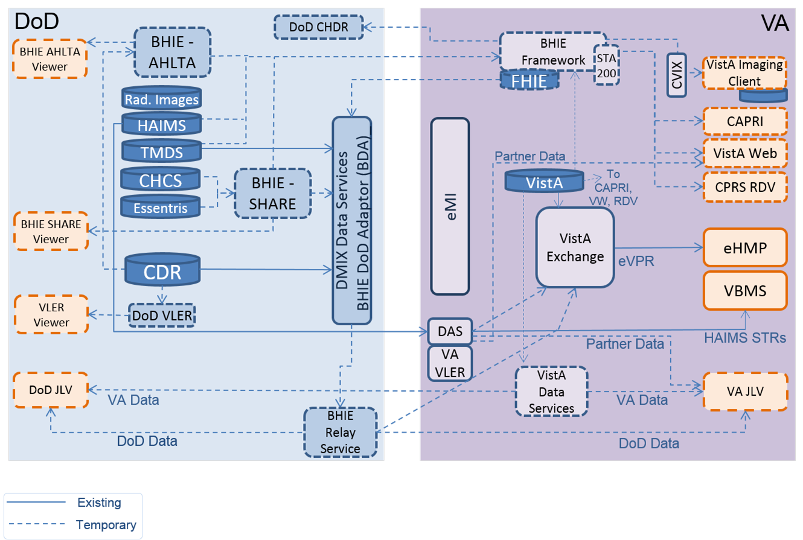

Figure 3 - Current state of VA-DoD interoperability[5]

The final stage of the DoD/VA Interoperability is shown in Figure 4, below. At that stage, DoD would have shifted to DHMSM product-managed, standards-based exchange with VA (and other external partners) and the VistA Evolution would have transitioned into long-term, ongoing sustainment activities.

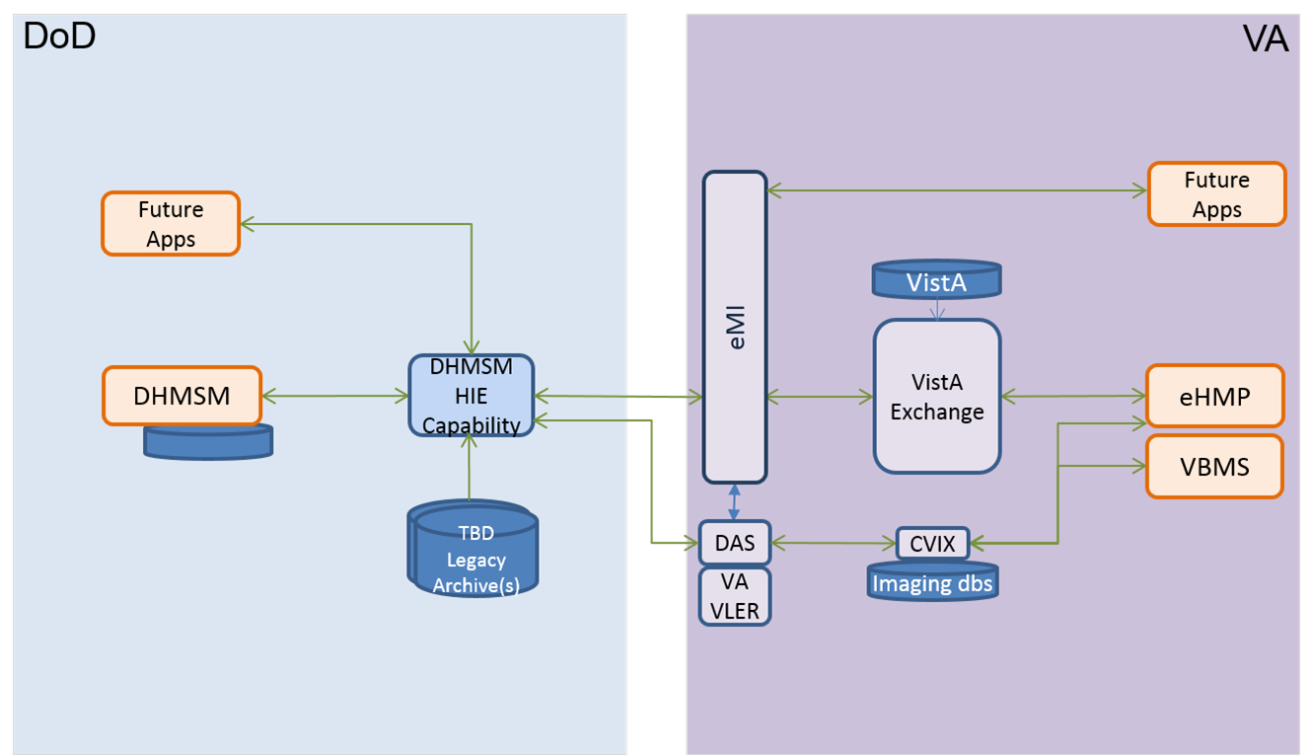

Figure 4 - DoD-VA Interoperability View: Full Operational Capability[6]

## Overview of the Significant Requirements

This SDD is based on requirements for iEHR Platform Deployment that are enumerated in the following documents.

* [eMI BRD](http://tspr.vista.med.va.gov/warboard/ProjectDocs/iEHR_SOA_Suite/VEPEO_SOA_Joint%20iEHR%20SOA%20Suite%20-BRD_RSD_201203.pdf)
* [SOA SID 032 System Requirements Specification/Business Requirements Specification](http://vaww.oed.portal.va.gov/pm/iehr/vista_evolution/SOA/Harris%20Deliverables/Forms/AllItems.aspx?RootFolder=%2Fpm%2Fiehr%2Fvista%5Fevolution%2FSOA%2FHarris%20Deliverables%2FSID%20032%20%2D%20System%20Requirments%20Specification%20%28SRS%29%20Plan&FolderCTID=0x012000EF462204F467BF48A3E4F3B191209E2C&View=%7bF648AE20-2F7D-4CE5-A735-335935507C9B%7d)

The eMI VII requirements can be found in the following documents.

* [Business Requirements Document](http://vaww.oed.portal.va.gov/pm/iehr/vista_evolution/emivii/PMAS%20Documentation/Business%20Requirements%20Document/VFA_VE_eMI_VII_BRD_20150504.pdf)
* [Requirements Specification Document](http://vaww.oed.portal.va.gov/pm/iehr/vista_evolution/emivii/PMAS%20Documentation/Forms/AllItems.aspx?RootFolder=%2Fpm%2Fiehr%2Fvista%5Fevolution%2Femivii%2FPMAS%20Documentation%2FRequirement%20Specification%20Document&FolderCTID=0x01200001D7858C9BB7B042901EBE8FB6E428E0&View=%7b2F660A8B-0163-42E0-8A08-66A8AB3A6EEA%7d)

# Conceptual Design

## Conceptual Application Design

### Application Context

The SOA Suite is implemented over an Infrastructure-as-a-Service (IaaS) provider with an architecture design based on VMs using VMware and the RHEL OS.

The SOA Suite project integrated, configured, tested, and deployed a system of COTS products to facilitate data sharing and application communication inside as well as outside VA among authorized and authenticated service providers and consumers of electronic healthcare information. The SOA Suite solution is designed to provide comprehensive messaging across VA. A high-level system design is provided in Figure 5.

Figure 5: High-level System Design



With respect to implementation, the SOA Suite stack uses an architecture that integrates IBM WebSphere products, Integration Bus, CA API Management Suite, and CA APM. (See 3.2, on page 19)

### High-Level Application Design

Figure 6 depicts the SOA Suite’s high-level application design.

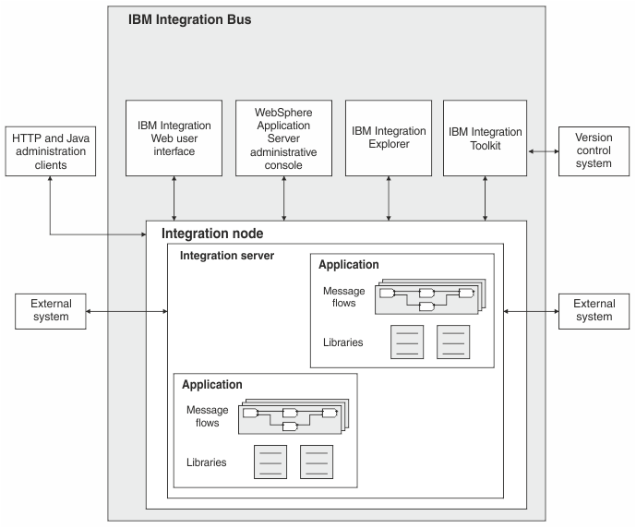

Figure 6 – High-Level Application Design[7]

### Application Locations

Figure 7 depicts the application locations.

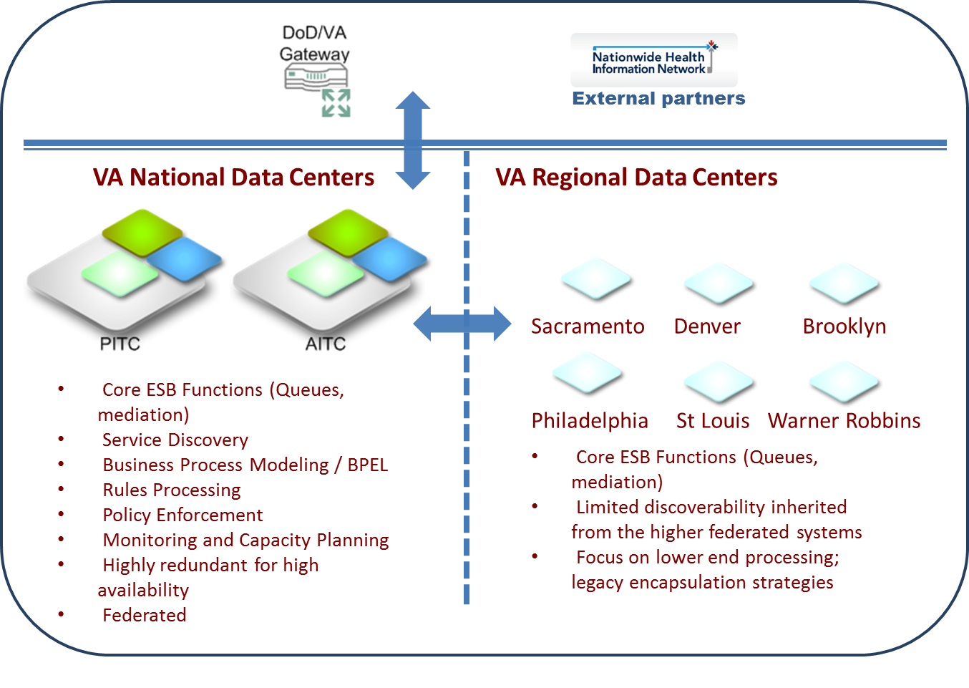

Figure 7 – Application Locations[8]

## Conceptual Data Design

Figure 8 depicts the conceptual data design.\



Figure 8 – Conceptual Data Design[9]

### Project Conceptual Data Model

N/A - The eMI SOA Suite is middleware software with no data storage other than message buffering.

### Database Information

N/A - The eMI SOA Suite is middleware software with no data storage other than message buffering.

### User Interface Data Mapping

N/A - The eMI SOA Suite is middleware software with no direct user access.

#### Application Screen Interface

N/A - The eMI SOA Suite is middleware software with no direct user access.

#### Application Report Interface

N/A - The eMI SOA Suite is middleware software with no direct user access.

#### Unmapped Data Element

N/A - The eMI SOA Suite is middleware software with no database or direct user access.

3.3.4. Conceptual Infrastructure Diagram

3.3.4.1. Location of Environments and External Interfaces

3.3.4.2. Conceptual Production String Diagram

## Conceptual Infrastructure Design

An integral component of eMI is the IBM Integration Bus (IB,) which is explained in greater detail below. Figure 9, below, depicts the SOI packages usage.

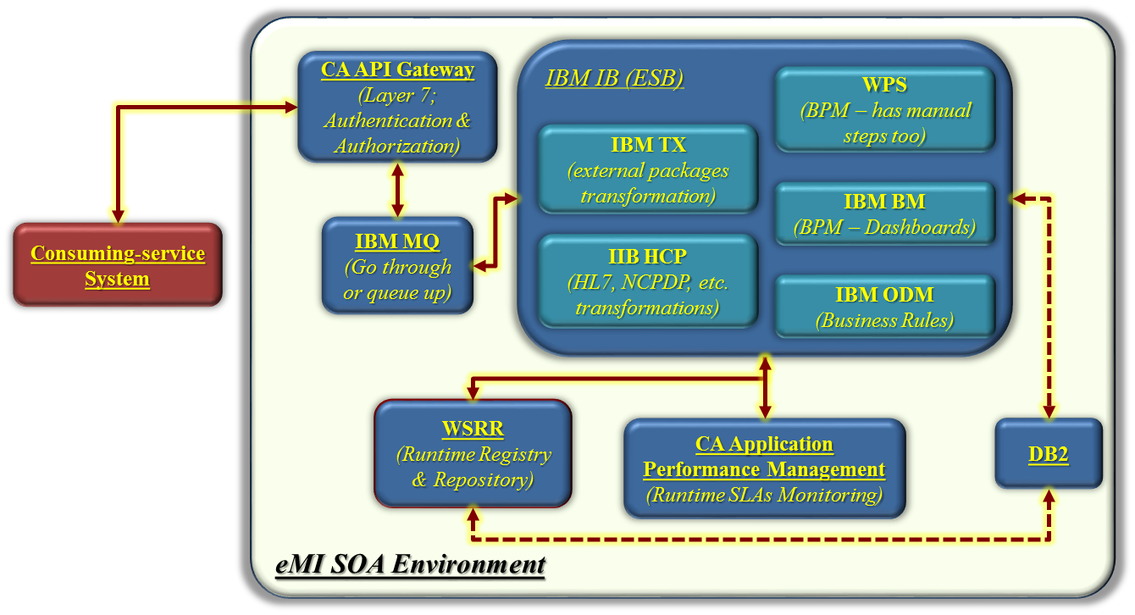

Figure 9 – SOI’s Primary Packages

Table 5, below, provides a list of COTS products that are configured alongside the IB to support the various SOA Suite capabilities. Table 5 identifies the SOA Suite software components as detailed in SID 049 Version Description Document.

Table 5 – SOA Suite Software Components

| COTS Product Description |
| --- |
| IBM WebSphere Process Server (WPS) |
| IBM Integration Bus family (formerly IBM WebSphere Message Broker; WMB) |
| IBM Integration Bus Healthcare Pack (formerly Healthcare Connectivity Pack for WMB) |
| IBM MQ (formerly WebSphere Message Queue; WMQ) |
| IBM WebSphere Data Server DB2 |
| IBM Business Monitor (formerly WebSphere Business Monitor; WBM) |
| IBM WebSphere Transformation Extender (WTX) |
| IBM Operational Decision Manager; ODM (formerly WebSphere Operational Decision Management; WODM) |
| IBM WebSphere Service Registry and Repository (WSRR) |
| CA Application Performance Monitoring (APM) |
| Integration Bus Connect with PostgreSQL |
| CA API Gateway (formerly Layer 7 SecureSpan Gateway; SSG) |
| Network Attached Storage (NAS) Network File Server (NFS) for Linux |
| IBM Hypertext Transfer Protocol Server (HTTP Server) |
| IBM Deployment Manager (DMGR) |

Each product brings a unique SOA Suite capability to support the migration of various systems in VA that are running locally on the enterprise stack. The following sections provide high-level details of the products listed in Table 5.

* **WebSphere Process Server (WPS):** WPS is the runtime engine for products resulting from the business-driven development process. WPS runs on top of the WebSphere Application Server (WAS) and extends the [IB ESB](http://en.wikipedia.org/wiki/WebSphere_Enterprise_Service_Bus). WPS is integrated with the [IBM Business Process Manager](http://en.wikipedia.org/w/index.php?title=IBM_Business_Process_Manager&action=edit&redlink=1) (BPM) suite. The configuration also offers built-in SOA components for extensive enterprise-wide service integration and orchestration. WPS provides a single BPM runtime environment that can support a range of business processes, service orchestration, and integration capabilities.
* **IBM Integration Bus family (formerly IBM WebSphere Message Broker; WMB):** IBM-IB is the core eMI SOA Suite ESB for the VA enterprise. Deployed at enterprise nodes, the IB is the core entry point for the stack of products that make up the eMI SOA Suite. The primary roles of IB within the eMI are message routing, message transformation, message enrichment, and publish/subscribe. Along with being an industry leading ESB, IB is used in the implementation of application integrations because it provides a mechanism for connecting, routing, and transforming business data from a variety of transports without any need to change the underlying applications generating the data.
* **IBM Integration Bus Healthcare Pack (formerly Healthcare Connectivity Pack for WMB):** The Healthcare Pack provides prebuilt patterns and connections for interoperability and device integration of clinical applications and healthcare systems. The package features:
  + Clinical application and device integration that supports Health Level Seven International (HL7)-based information flows.
  + Patterns and connectors that support the integration of remote patient monitoring devices
  + Prebuilt, healthcare-specific tools that accelerate integration deployments in healthcare organizations
  + Deployment and configuration capabilities that can simplify integration setup and maintenance

The package, in addition to offering – as the rest of the IBM SOA-based tools – operational and web-based monitoring, provides the eMI application teams with tools to develop message flow applications, to integrate with HL7, NCPDP, etc. applications, to use data from medical devices in message flows, and to audit data from message flows as well as to analyze healthcare data in message flows.

* **IBM MQ (formerly WebSphere Message Queue; WMQ):** MQ provides the basic message queuing infrastructure for the core eMI SOA Suite ESB at the RDCs. It also provides the reliable mechanism for all communications between different sites.
* **IBM WebSphere Data Server DB2:** DB2 is a relational database management system provided for free by IBM to support various other IBM SOA Suite components like WSRR and WODM.
* **IBM Business Monitor (formerly WebSphere Business Monitor: WBM):** IBM-BM is comprehensive business activity monitoring software that provides an up-to-date view of business performance. It also provides predictions so that stakeholders can take action before process problems occur. BM supports customizable dashboards to process business events and data and calculate key performance indicators and metrics.
* **IBM WebSphere Transformation Extender (WTX):** Integrates industry based customer, supplier, and business-partner transactions (from outside the VA) across the VA enterprise.
* **IBM Operational Decision Manager; ODM (formerly WebSphere Operational Decision Management; WODM):** ODM is deployed on a standard WAS production architecture. There are a variety of protocols supported for accessing the Rules Execution Servers from the ESB or BPM components, including Web services, Service Component Architecture, Java Message Service, and MQ.
* **WebSphere Registry and Repository (WSRR):** WSRR is the master metadata repository for service descriptions. WSRR provides registry functions that support publication and consumption of metadata regarding the function, requirements, and semantics of services. WSRR provides repository functions to store, manage, and assign a version number to service metadata and supports governance of service definitions. IB is integrated with WSRR to search and retrieve the dynamic endpoint of the various services registered in eMI.
* **CA Application Performance Management (APM):** eMI SOA Suite will use APM to monitor the ESB components. The APM Workstation will be used to view and manipulate data that is stored by the Enterprise Manager. APM is the established standard within VA’s Corporate Data Center Operations for performance monitoring of Web applications and Web services. The APM application is also part of VA’s Enterprise Management Framework.
* **Integration Bus Connect with PostgreSQL:** PostgreSQL is a powerful, open source object-relational database system. “Inflight” information regarding eMI-mediated transactions will be kept there. Such information will be primarily related to transactions with legacy VA systems that have no SOA-based services interfaces. The status and state of such transactions will be persisted in PostgreSQL in case of errors in the transaction sequence. The information will be kept in the database and the further processing of such information will be explicitly determined and described in the requirements document that would govern this legacy-system affiliated transaction.
* **CA API Gateway (formerly Layer 7 SecureSpan Gateway; SSG):** The eMI SOA Suite uses CA API Gateway, which protects applications exposed as Web services, connects applications across security and identity domains, and validates policy compliance across a transaction. The CA API Gateway is an XML firewall and service gateway designed to protect Web services, accelerate XML operations, and mediate communications between SOA clients and services residing in different identity, security, or middleware domains. The CA API Gateway Policy Manager is a graphic user Interface-based application that allows administrators to centrally define, offer provision, verify, and audit fine-grained security and connectivity policies for cross-domain Web services and XML integrations on the SSG. The Policy Manager is available as software for RHEL or Microsoft Windows server environments. There is also a browser-based version that requires no additional installation.
* **Network Attached Storage (NAS) Network File Server (NFS) for Linux:** A file-level computer data storage server connected to the NFS providing data access to a heterogeneous group of clients.
* **IBM Hypertext Transfer Protocol Server (HTTP Server):** Web Server.
* **IBM Deployment Manager (DMGR):** The Deployment Manager is a special WebSphere instance responsible for managing the installation and maintenance of applications, connection pools and other resources related to a J2EE environment. It is also responsible for centralizing user repositories for application and also for WebSphere authentication and authorization. The Deployment Manager communicates with the Nodes through another special WebSphere process, the Node Agent.

Products listed in Table 5, comes with a set of development tools to support development activities. The following sections provide a high-level overview of each development tool’s usage.

* **IB Toolkit** This is the development environment for message flow applications and associated resources such as Extended Structured Query Language, Java, mappings, and message definitions. These message flow applications are deployed to the runtime components using the Toolkit.
* **Message Queue Explorer Toolkit.** MQ Explorer is a graphical administration tool for creating, modifying, and deleting MQ resources and for monitoring the MQ network. MQ Explorer is an optional component of WQ, although it is installed by default when you run the “Typical” MQ installation.
* **WSRR Studio.** WSRR Studio is used to configure WSRR configuration profiles using Universal Markup Language modeling tools to manipulate artifacts (Web Services Description Language, XML Schema Definitions, etc.) in WSRR and to produce custom reports using the Business Intelligence and Reporting Tools reporting framework.
* **Rational Application Developer.** Rational Application Developer for WebSphere software accelerates the development and deployment of Java, Java Platform Enterprise Edition, Web 2.0, mobile, Open Service Gateway initiative, and portal and SOA applications. Both expert and novice developers can increase productivity and efficiency by using the integrated capabilities of Rational Application Developer for easier development, testing, analysis, and delivery of applications.
* **Integration Designer.** Integration Designer is a complete authoring environment that can be used for end-to-end integration in a SOA Suite. Based on Eclipse, Integration Designer is a tool for building SOA-based business process management and integration solutions across BPM. Integration Designer simplifies integration with rich features that accelerate the adoption of SOA Suite by rendering existing information technology assets as service components, encouraging reuse and efficiency.

### System Criticality and High Availability

#### High Availability Configuration

Multi-instance queue managers improve the availability of WebSphere MQ applications. In configuring for reliability and availability, you trade off a large number of factors, resulting in the following four distinct design points.

* **Disaster recovery**: Optimized for recovery after a major disaster that destroys all your local assets; disaster recovery is based on geographic mirroring.
* **Backup**: Optimized for recovery after a localized failure, commonly a human error, or some unforeseen technical problem, MQ provides backup queue managers to back up queue managers periodically. One could also use asynchronous replication of queue manager journals to improve the currency of the backup.
* **Availability**: Optimized for restoring operations quickly giving the appearance of a nearly uninterrupted service following foreseeable technical failures such as a server or disk failure. Recovery is typically measured in seconds, with detection sometimes taking longer than the recovery process. A multi-instance queue manager is designed to assist in configuring for availability.
* **Continuous operation**: Optimized for providing an uninterrupted service; continuous operation solutions have to solve the detection problem, and nearly always involve submitting the same work through more than one system and either using the first result, or if correctness is a major consideration, comparing at least two outcomes.

A multi-instance queue manager is designed to assist in configuring for availability. One instance of the queue manager is active at a time. Switching over to a standby instance takes as little less as ten seconds to fifteen minutes or more, depending on how the system is configured, loaded, and tuned[10].

A multi-instance queue manager can give the appearance of a nearly uninterrupted service if used with “reconnect-able” WebSphere MQ clients, which are able to continue processing without the application program necessarily being aware of a queue manager outage.

#### High Availability Configuration

High availability in the VA/iEHR environment is achieved by utilizing both hardware and software components. The sections below outline how these components are implemented and how they contribute to the overall goal of maintaining the highest rate of availability for VA/iEHR.

The first method employed to assist in achieving the highest availability of the integration is to utilize redundancy in physical components within the architecture. This includes network connectivity, hardware components, software, and applications.

The second method employed to assist in achieving the highest possible availability is to utilize a “failover” methodology. The failover capabilities can be provided by software that is developed specifically for that purpose or scripts and procedures that can be developed internally. In order to provide the best-automated failover mechanism, additional software is required.

One key component in a failover methodology is the ability to share access to data across machines. This allows an available machine to access data for a failed machine without the loss of data. This requires that the data be stored on a high-speed, fault-tolerant storage medium, such as a Storage Area Network (SAN) device. The SAN array used at a regional location must be capable of supporting 74,000 input/output operations per second in order for the SOA Suite to meet the threshold and objective performance requirements. All SOA Suite VM servers must have multi-path connections on the SAN fabric through the backplane of the VMWare/VCenter/VSphere infrastructure to be provided by the government at regional and local site deployments. As such, it is critical that the SAN and the VM configurations be partitioned on the blade servers in a manner that allows for VMotion capabilities to be leveraged. This is, in fact, a key underlying requirement for the high availability, clustering, and failover methodology specified in this SDD and for the SOA Suite architecture described herein.

##### Physical Redundant Architecture

Redundancy in hardware is achieved by deploying hardware that is configured with multiple components to support the up time and availability of the machine. This includes, but is not limited to, such things as power supplies, network cards, and mirrored or other high available disk configurations. This also is a normal process performed by hardware technicians and therefore is not covered in detail in this document. EO is responsible for maintaining eMI’s redundancy.

Figure 10 below is the illustration of the physical redundancy.

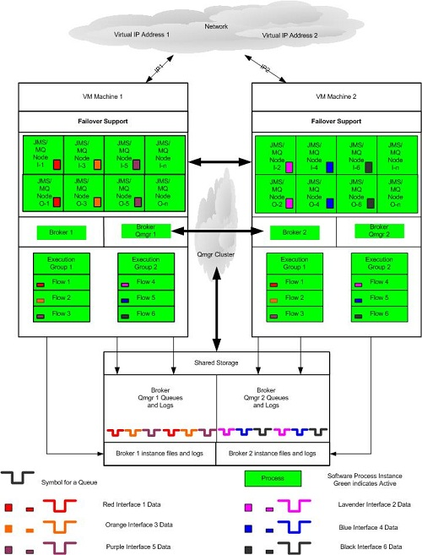

Figure 10 – Physical Redundancy[11]

Figure 10 shows that redundancy is achievable within the broker flow domain. A flow developed to process a given message is deployed in execution groups on multiple machines. MQ clustering is utilized to route message traffic between the nodes and each of the brokers.

##### Broker and Flow Redundancy

The basic requirement within IB in implementing an active/active high available solution is that the message flows must be able to process messages as independent entities. Any flow that processes messages in a transactional mode can be deployed in multiple execution groups in multiple brokers. Brokers are only groupings of execution groups, and execution groups are groupings of message flows and message sets. Therefore, any broker or execution group can be a clone of another by deploying the same message flows and message sets to them.

There are instances where messages have relationships that must be maintained. These requirements will need additional design when attempting to implement a redundant architecture. In some cases, additional processes, tools, or components can be implemented to maintain the relationships and still allow the messages to be processed in an active/active parallel processing implementation.

By implementing this solution, all identified flows can be deployed in an active/active high availability solution. MQ will be the traffic cop that routes messages between the redundant message flows across brokers.

##### Failover

There is no absolute guarantee that a failure will only occur at a time when there are no messages that have not completed processing. MQ will assure that messages will not be lost as long as the rules for persistent and recoverable messages are followed. The flows within IB should be written in transaction mode and should follow all rules to ensure no message is lost during a failure.

It is possible that a message would be at a point in the process that when a failure occurs, that message will be unavailable until the failed component is restarted. Therefore, a “failover” solution must also be implemented to allow for the timely completion of processing for any given message.

Failover software or procedures will to be implemented on each machine that can participate in the failover process. Each component, MQ and IB, must have their files and all other runtime files defined on a shared storage device. Each one must be installed and configured to designate each instance of the components uniquely. This is required so that any directories or mount points are shared between machines during a failover.

#### Workload Balancing

Workload balancing in the VA/iEHR environment is achieved through both design and planning of workload placement and parallel processing within the broker flows.

Flows should be deployed in a manner to enhance the parallel processing capabilities of IB. Each flow should be deployed to at least one execution group on each of the broker machines. This provides the first step in parallel processing and provides enhanced availability. If a machine goes down, there is still a flow running on the other machine to process the data for that flow.

Parallel processing can also be enhanced by increasing the number of instances of a flow within each execution group. Further enhancement can be achieved by deploying a given flow with multiple instances to more than one execution group within the same broker. The number of instances of any given flow will be an ongoing tuning exercise to balance message throughput against machine resources.

#### MQ Clustering

MQ clustering should be used to manage the distribution and balancing of the messages between the two broker machines. By defining queue managers as clustered queue managers and queues as clustered queues, MQ will distribute the messages to both queue managers for both brokers, one on each broker machine. MQ will be aware of the availability of the queue managers and queues and only distribute messages to available queues.

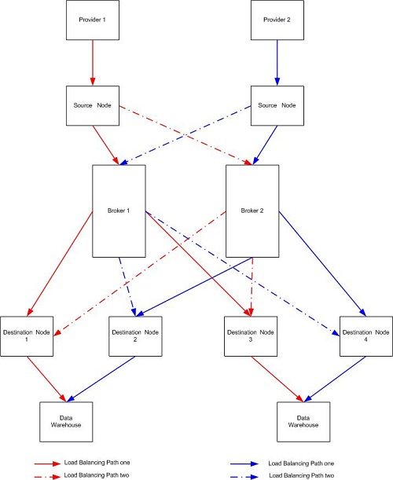

Figure 11 – Clustering and Message Flow[12]

In Figure 11, the arrows are color coded to indicate the flow of messages from source to destination through the different brokers depending on which broker queue manager was next in line to receive data. The solid lines depict one path, and the hyphenated lines depict the alternate path for a subsequent message of the same type. A specific source will only send messages to a specific source node. The node will put the message to a MQ queue for processing by the broker. Using MQ clustering and parallel processing through redundant brokers and flows, the message could be processed by either broker. No matter which broker processes the messages, the destination message will be routed to a specific MQ queue that will be input to the data warehouse portion of the processing.

### Special Technology

N/A - The eMI SOA Suite requires no special technology.

### Technology Locations

Table 6 (Grouping) – Technology Locations

| Technology Component  RDC Production | Location | Usage |
| --- | --- | --- |
| 16 VMs, 8 Load Balancers | Brooklyn | Regional Message Exchange |
| 16 VMs, 8 Load Balancers | Denver | Regional Message Exchange |
| 16 VMs, 8 Load Balancers | Sacramento | Regional Message Exchange |
| 16 VMs, 8 Load Balancers | Philadelphia | Regional Message Exchange |
| 16 VMs, 8 Load Balancers | St Louis | Regional Message Exchange |
| 16 VMs, 8 Load Balancers | Warner Robbins | Regional Message Exchange |
| Technology Component  AITC Production | Location | Usage |
| 16 VMs, 8 Load Balancers | Austin | Central Message Exchange |
| Technology Component  PITC Recovery Backup | Location | Usage |
| 16 VMs, 8 Load Balancers | Philadelphia | Backup Central Message Exchange |

### Conceptual Infrastructure Diagram

Figure 12 depicts the high-level notional operational concept for the SOA Suite, with enclave boundaries, as deployed for the Enterprise level at the VA AITC and PITC sites and the RDC sites.

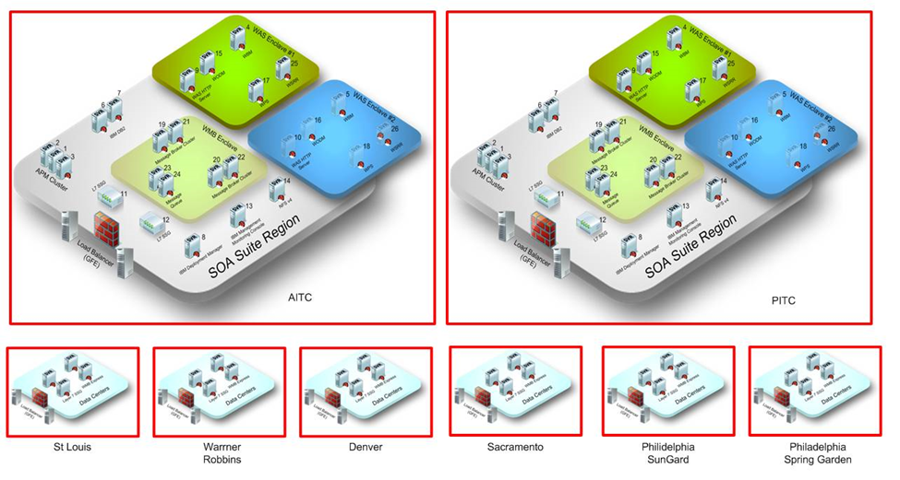

Figure 12 – High-Level Notional Operational Concept for the SOA Suite with Sites and Enclave Boundaries[13]

#### Location of Environments and External Interfaces

Currently[14] in eMI, as it is shown in Figure 13, below, the following four environment are associated with the VII (Phase I) effort.

Figure 13: eMI VII environements



#### Conceptual Production String Diagram

This section describes the conceptual design of the application in the context of the overall business.

The SOA Suite provides a messaging infrastructure that allows medical data transmission, such as orders and results, to flow between applications. Because of the complexities of medical record exchanges, such as mediating terminologies, simply transmitting messages is insufficient to provide interoperability between provider and consumer applications in an exchange. To that end, the ESB provides service and interoperates with other services to provide value-added work in support of the record exchanges. Some of the services supported by the SOA Suite are shown in Figure 14.

RepresentativeSOA Services

Figure 15 – Representative SOA Services[15]

The SOA Suite provides two classes of services out of the box that require integration and customization: security services and infrastructure services. The security services are provided by the CA API Management Suite (Layer 7 SSG.) The security services included out of the box are Security Assertion Markup Language (SAML) service, authentication service, and certificate management service.

A set of COTS infrastructure services will be provided as part of the SOA Suite. These services may be divided into routing services and data services. The routing services include rules engine, Business Process Execution Language (BPEL) service, and the business processing service. The data services include protocol conversion service and Common Information Model transformation service.

# System Architecture

## Hardware Architecture

This section outlines the decisions for the design approach. Because of the message processing nature of this project, deployment is designed based on the initial performance requirements. Those requirements are based on message throughput through the ESB. The reasoning behind using the performance requirements provided in the PWS are that those numbers match VA usage statistics provided in the Request for Task Execution Plan as well. These requirements are outlined in the performance requirements section of this document.

The SOA Suite deployment is completely on virtualized hardware. Per the PWS, no hardware was to be procured on this contract. Because of this, CA API Management Suite will be virtualized as well and not a hardware device. Since this is a virtual environment, performance improvements come through the addition of IB VMs into the cluster. VM infrastructure will follow the VA’s current model to minimize technical and schedule risks.

* VMWare 4.1 or greater
* RHEL 5.10 or greater
* Thin provisioning

eMI is using these packages as part of the EO/AITC Platform as a Service (PaaS). Changes to the packages status, versions, and TRM-compliance are controlled by the EO plans and they will affect and be reflected promptly on the eMI roster of tools. Deployment to the virtualized infrastructure will occur by laying out STIGed VMs as Open Virtualization Appliance (OVA) into the target data center. Post-deployment installation, such as creating local WAS profiles will occur.

* Reduces the deltas between installations
* Allows for the VMs to be tested earlier in the process

MQ is used for Integration Bus communications (generally between regions). The reasons for this are:

* Better reliability and quality of service than using Minimal Lower Layer Protocol (MLLP), Hypertext Transfer Protocol (HTTP), etc.
* Can be encrypted
* Higher performance
* Can be wrapped in a Java Messaging Service interface to prevent vendor lock-in

ESB capabilities in IB, ODM, etc. are to be used for routing logic and not clinical decisions. This prevents the spread of application logic that lacks cohesion. It also helps keep the logic from becoming highly coupled to the ESB.

Sample implementations and Software Development Kits (SDKs) will be developed in Java. Several reasons for this are:

* High penetration in VA
* Supported natively by the IBM development tools and much of the application stack

Sample implementations and SDKs will try to match the iEHR goals. This enables the SOA Suite team to provide relevant samples and SDKs that will help ease integration efforts.

To support security, CA API Management Suite will be the certificate store and will centralize the management of certificates. The deployment of the regional CA API Management Suites will be in an enterprise-wide cluster. Clustering in this way provides a guaranteed consistent set of policies as well as redundancy.

When possible, load balancing is self-provided by IBM products. CA API Management Suite requires a load-balancer. F5 is the load balancer of choice because of its current use in the enterprise, but the EMI Team’s solution will support any standard load balancer.



Figure 16 – RDC Design[16]

The SOA Suite eMI architecture consists of VMs distributed centrally in the AITC and remotely in six RDCs in redundant configurations. Detailed systems configurations are in Section 6 of this document.

## Software Architecture

To meet SOA Suite requirements, each host will be configured identically with the exception of hostname, IP, and iSCSI Qualified Name. Accessible storage and networks need to be identical. A minimum of two dedicated heartbeat datastores, each on a different physical storage node, are required.

Each guest machine has VMtools installed and by default is configured to auto start. VMtools monitoring should be enabled and set to hard restart at sixty seconds of continuous loss of the machine heartbeat.

Leveraging VMware affinity or anti-affinity rules is also highly recommended. No identical instances of a product should be allowed to reside on the same host. For example, no more than one instance of IB will reside on any given host. Detailed COTS information is in Section 6 of this document. Figure 16, below, depicts the high availability topology of SOA Suite VMs.

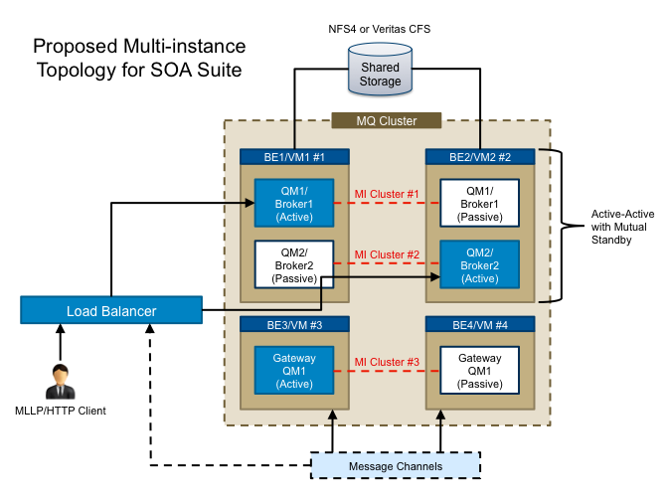

Figure 17 – Multi-Instance Topology for SOA Suite[17]

This design has the following important features to provide high availability.

* MQ clustering provides load balancing and redundancy.
* Multi-instance queue managers and brokers provide failover capability; active and passive instances use shared file systems.

The following are considerations for multi-instance MQ and IB.

* Prerequisite is implementation of shared network storage using clustered file systems, e.g. NFSv4.
* Clustered file system is a key capability for this technology to work and must be configured properly.
* IBM recommends the use of multi-instance technology.

At the hardware level, each member of the WebSphere Application Server (WAS) Cluster is in a different hardware node on a different blade server. Each Web server is located in a different blade server as well. At the application level, application servers or messaging application servers are located on separate nodes and are managed together through a cluster configuration. So if one of the application servers goes down, the work load is handled by the surviving application Server.

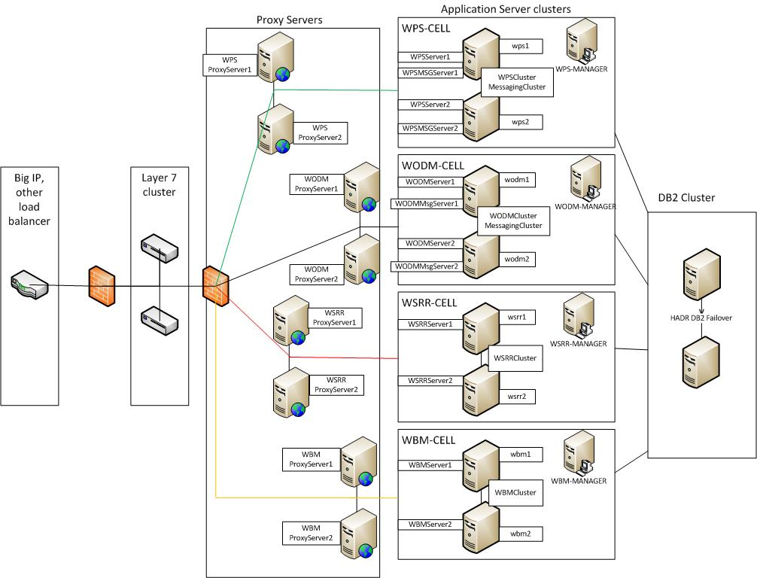

Figure 18 – High Availability Deployment Architecture[18]

In the WAS environments at the Development Test Environment (DTE), there are four COTS products: WPS, Business Monitor (BM,) ODM, and WSRR. Each of these is hosted in a cell that bears the name of the COTS product. Each node is identified by the product name and servers in the cell are named and numbered for the product and the node number; each is supported by a DB2 database that is also clustered.

Traffic to an application server cluster is managed through the Web servers that route traffic using WebSphere’s plugins. If one of the application servers that is getting traffic goes down, the plugin intelligently manages the traffic so that no traffic is sent to the downed application server. Figure 17 shows the deployment architecture.

### Interfacing with External Partners

Regarding external partners, eMI’s initial interface is DoD. DoD and VA have many years of experience doing query/response-based interoperability focused around the now legacy BHIE Framework set of systems. As it is being discussed below a plan to fully transition from this legacy BHIE Framework-centered environment to the new interoperability platforms that DoD and VA have established has been defined. Importantly, this plan incorporates existing DoD and VA strategies and plans with regards to DoD/VA interoperability data services and viewers into a single, joint plan. Further, the plan anticipates emerging interoperability standards as well as the Office of the National Coordinator (ONC) for Health Information Technology’s recently released Interoperability Roadmap[19].

Regarding eMI’s VII project, “Phase I” planning has determined that the following goals will be accomplished:

1. Establish a connection between DMIX’s DES and VA’s eMI. This will require the routing of DoD data to VistA Exchange via eMI. This will be a joint DoD and VA effort, scheduled to be finished by Q4FY15.
2. Establish a connection between eMI and eHMP’s VistA Exchange. This will also be a joint DoD and VA effort, scheduled to be finished by Q4FY15.
3. Eliminate the connection between BHIE Relay Service and eHMP’s VistA Exchange. This is a temporary (transitioning or intermediate) solution. It will require the routing of DoD data to VistA Exchange via eMI. This is also a joint DoD and VA effort, scheduled to be finished by Q4FY15.
4. Eliminate DoD VLER, VLER Viewer, BHIE Share Viewer, BHIE AHLTA Viewer.  
   This will require the consolidation of DMIX adapter and viewer (v.3 and v.4.) This effort is concerning the DoD only and it is scheduled to be finished by Q4FY15 or Q2FY16.
5. Establish a connection between AFHSC Database and DMIX’s DES. This will also require the consolidation of DMIX adapter and viewer (v.3 and v.4.) This effort is concerning the DoD only and it is scheduled to be finished by Q4FY15 or Q2FY16.

In Figure 3 (page 14,) and Figure 4 (page 15,) the following VA applications involved in VII “Phase I” are shown.

#### eHMP and VistA Exchange

Currently, eHMP includes the following two major components (shown in Figure 18 below.)

* eHMP Web Application: Provides functionality to support a clinician at the point of care with a patient. It is the application that will ultimately perform many of the functions of CPRS, and utilizes VistA Exchange as its source of patient data. The web application is developed as a Single Page Application, with client-side model view controller (MVC). The application provides a development time Software Development Kit (SDK) and a runtime container in which small units of functionality can be developed and executed.
* VistA Exchange: VistA Exchange is responsible for providing an enterprise patient record, including data from the VA and DoD. Based upon business triggers (such as an appointment, admission, or patient search), VistA Exchange begins to aggregate data from source systems for a selected patient. The data is normalized using standard terminologies to include consistent terms; the data store is indexed to ensure rapid retrieval based upon the patient identifier or through free text search. In addition to getting data from the local site, Vista Exchange retrieves data from remote VA and DoD sites via Clinical Data Service and the DoD adaptor, respectively. Eventually, the majority of VistA Exchange data will be retrieved from VistA via a publish-subscribe (pub/sub) design pattern.

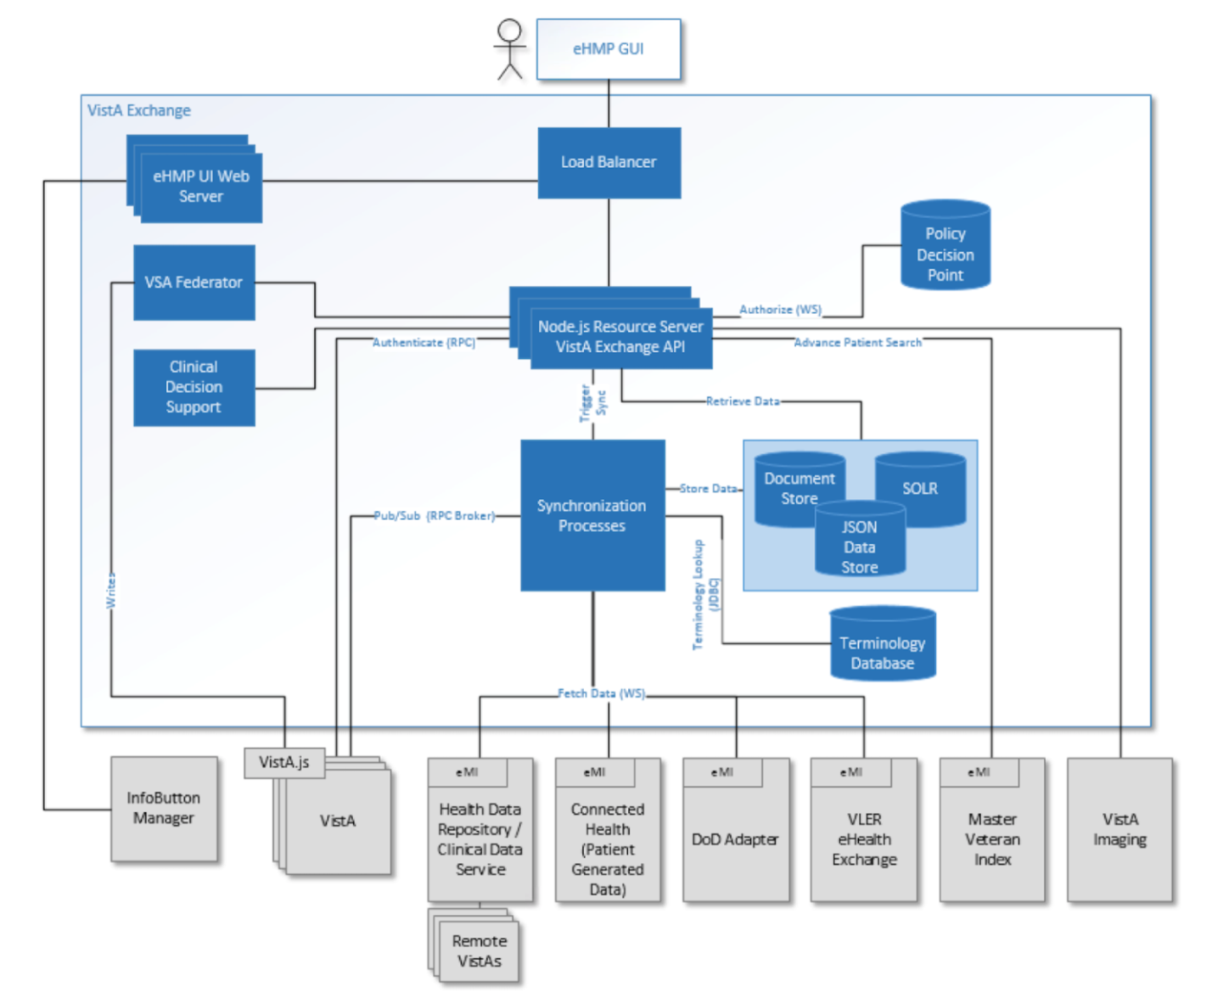

Figure 19. eHMP Architecture[20]

#### DAS and VLER

* VLER DAS: It serves as a proxy between consumers and producers of VLER data. Consumers initiate all data transactions. The VLER DAS interacts with Identity Management and VAP to ensure that all such data transactions maintain the integrity of personal data associated with individuals and enforce all related security and privacy policies. All other interfaces with VLER DAS are supporting interfaces to the VLER DAS’s primary role as serving as a VLER proxy between consumer and producer services. The system performs two main business functions:
  + Bidirectional Exchange of structured and unstructured information within the VA and other provider partners
  + Correlation of patient identities between VA and other provider partners including DoD
* VLER: The VLER Core includes the basic building blocks required for enterprise wide benefits & health data exchange, and is a critical dependency for multiple business initiatives and IT projects both within and outside of the scope of VLER.

The system’s architecture is shown in Figure 19 below.

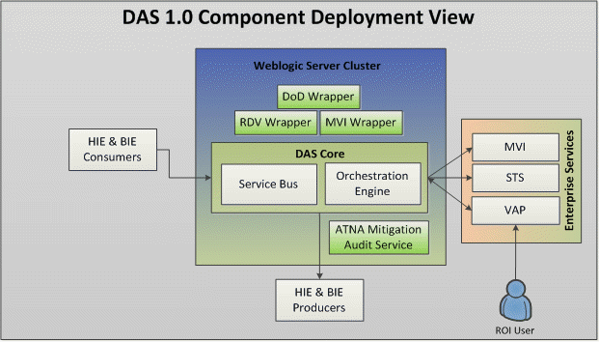

Figure 20. DAS & VLER, System Architecture[21]

The DAS System is a Java Enterprise Edition (JEE) Application which contains the following application modules: DAS Core Components, ATNA Mitigation Audit Service, DoD Wrapper Component, RDV Wrapper Component, and MVI Wrapper Component

The DAS core components use a *Message Bus* Architectural Style (design pattern). The message bus architecture describes the principle of using a software system that can receive and send messages using one or more communication channels, so that applications can interact without needing to know specific details about each other. It is a style for designing applications where interaction between applications is accomplished by passing messages (synchronously or asynchronously) over a common bus. DAS implementation consist of individual applications that communicate using common schemas and a shared infrastructure for sending and receiving messages. The message bus can be implemented via any of the major ESB vendors’ packages.

#### CVIX and VistA Imaging Client

* **VistA Imaging** provides image storage, DICOM gateways, Background Processor, and Clinical Workstations required by VistA Imaging. Delivers patient images integrated with CPRS to clinicians’ workstations throughout the VA enterprise for use in patient care. Provides interfaces to COTS imaging systems at VA medical facilities. Ensures image integrity and compliance with retention requirements for scanned documents and clinical images.
* **CVIX Major Functions** 
  + Provide Department of Defense (DoD) images to VA clinicians.
  + Provide VA images to DoD clinicians.
  + Provide VA images to users of VistAWeb and the *Advanced Web Image Viewer* (AWIV)
  + Host the VistA Site Service, the repository of connection information used by various Imaging components.
  + Host the VIX log collector.

Figure 20, Figure 21 and Figure 22 show the most relevant to eMI functionalities of the system:

* **CVIX provides DoD Images to VA Clinicians**: The CVIX provides a single point of access to the various DoD image sources for shared VA/DoD patients (that is, patients with IDs that are correlated in the VistA Master Patient Index). VA clinicians at sites that have implemented a VIX can access these images via the CVIX using the Clinical Display and VistARad applications.
* **CVIX provides VA images to DoD requestors**: The CVIX is also the portal used by all DoD clinicians to access VA images for shared VA/DoD patients. DoD clinicians can access non-DICOM medical images and scanned documents from all VA sites via the CVIX.
* **CVIX provides VA images to AWIV**: The CVIX serves as the image access portal for the AWIV. The AWIV is a browser-based application used to access VA medical images, primarily for non-clinical purposes. AWIV users can access any image or report associated with a VA Progress Note or a VA Radiology package report via the CVIX. The CVIX handles all connections with VA sites, insulating the AWIV from connection information changes.

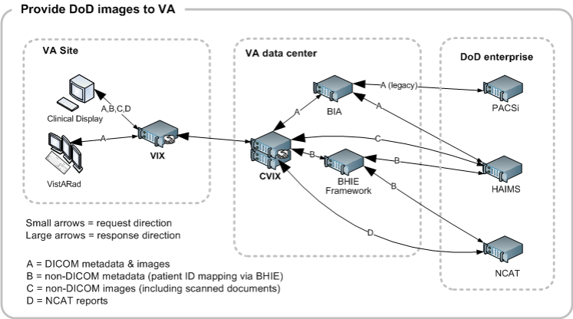

Figure 21. CVIX and VistA Imaging Client – System Architecture; DoD images to VA[22]

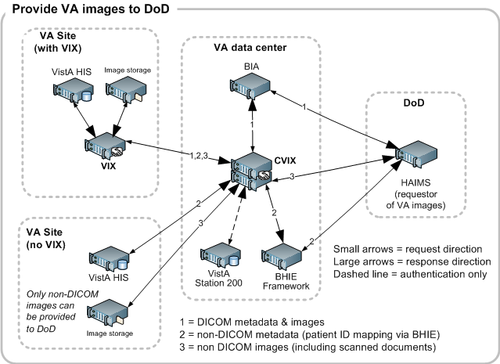

Figure 22. CVIX and VistA Imaging Client – System Architecture; VA images to DoD[23]

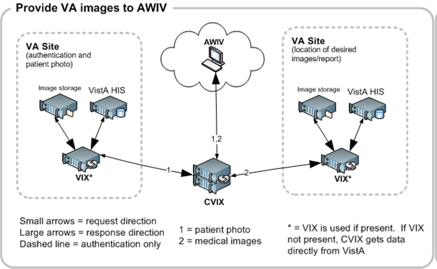

Figure 23. CVIX and VistA Imaging Client – System Architecture; VA images to AWIV[24]

### CPRS RDV and VistA Web

This system is an alternative solution to Remote Data Views (RDV):

* RDV is accessed through CPRS
* RDV functionality allows clinicians to view a patient's record from other VA and DoD facilities
* Remote data is accessed utilizing a visitor account with permission set within CPRS.

Currently, VistAWeb duplicates RDV. Clinical data available in RDV is also available in VistAWeb; however the view may look slightly different.

## Network Architecture

As demonstrated in Figure 23, the current state of connections within VA is quite complex. Multiple gateways are required for information to pass between various enclaves. Many system-to-system interfaces exist to transport information between various applications.

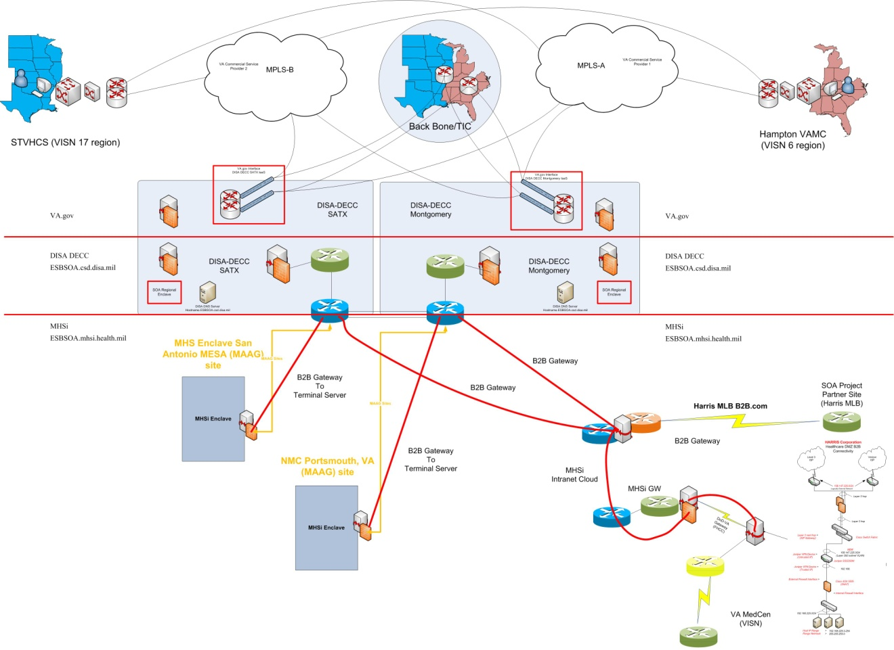

Figure 24 – VA Network Interfaces[25]

SOA Suite has two logical levels of operation: a regional level and a local level. Each region will have the full power of the ESB deployed, including the stack of software and its accompanying functionality. The local level deployment will include a lighter weight software stack that does not require the hardware or processing power that the regional deployment does but will still deliver powerful message processing and throughput capabilities. Protecting and connecting the local and regional communications channels are the CA API Management Suites. Each region will have the capacity to talk with every other region. The regional deployments will be copies of each other so that they will be able to provide failover for high availability in case one region crashes. A local site will have a single region that it communicates with (to support failover, they will have a backup region should their preferred region go down). As new services come on board their registry and availability will be managed by the WSRR instances in each region. The region will also be where the routing and transformation logic lives. The VII Production environment is shown in Figure 24, below.



Figure 25 - VII Production Environment[26]

In more details, the flow of transactions is shown in Figure 25, below.



Figure 26 - Transaction Details[27]

## Service Oriented Architecture / ESS

eMI is an SOA-based infrastructure. Through the use of the COTS packages that exist in the eMI SOI, SOA best practices have been implemented in accordance with the ESS guidelines. The [eMI wiki](http://vaww.oed.portal.va.gov/communities/VAeMI/eMI%20WIKI/eMI%20IT.aspx) describes in details the eMI’s adherence to ESS guidelines. In Figure 26, below, the overarching SOA component architecture is shown.

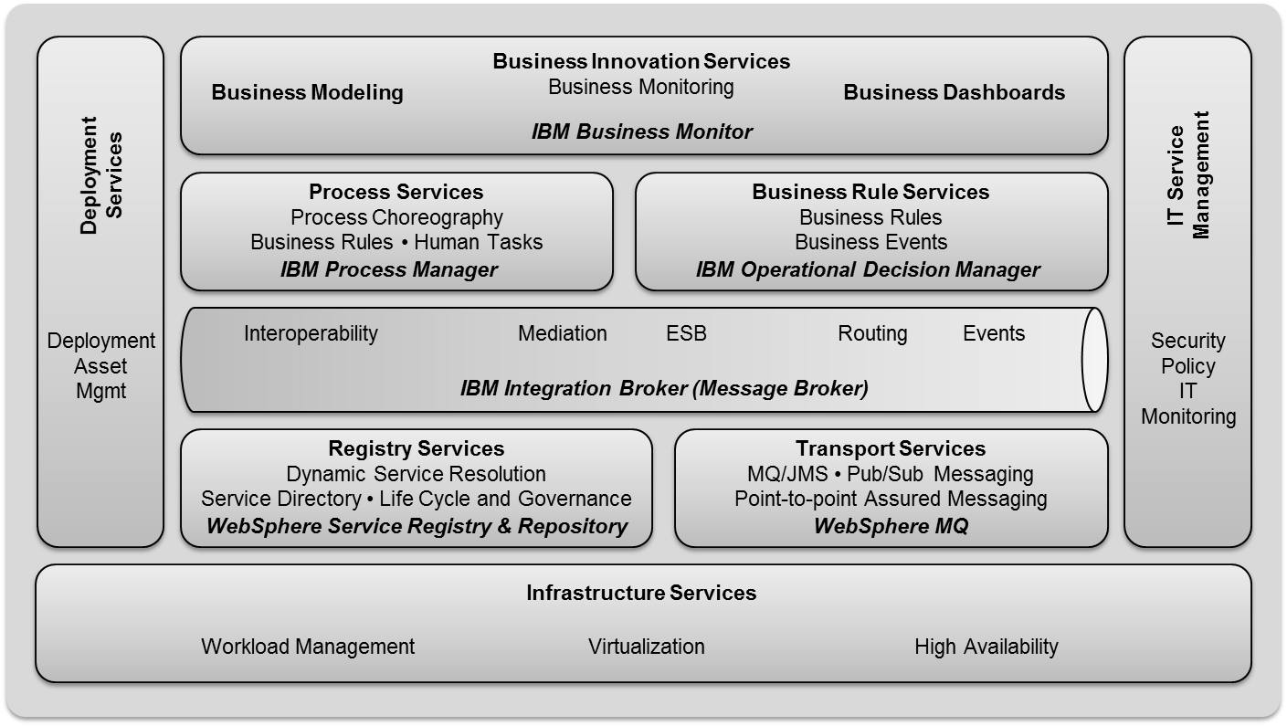

Figure 27. eMI SOA components[28]

## Enterprise Architecture

The SOA Suite resides between a number of VA consumers and providers to enable message exchanges between those systems, as shown in Figure 32.

The logical architecture for eMI consists of several key components. Figure 27, below, represents the federated view of the architecture, with key sections designated by color. eMI provides everything in the red and green boxes. A description of each area is contained in Table 7 below.

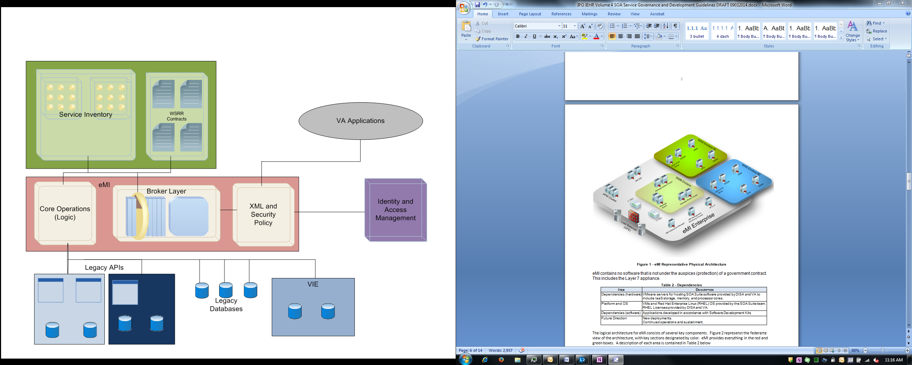

Figure 28. Logical Architecture of eMI, Federated View[29]

Table 7. Description of Logical Segments

| Area | Application | Products | Purpose |
| --- | --- | --- | --- |
| ESB Logic Layer  (Red) | XML and Security Policy | CA API Gateway | Enforces access control and policy regimes |
| Broker Layer | Message Broker and Message Queue | Guarantees and Persistent messaging, Quality of Service controls, scaling and demand based consumption |
| Core Operations (Logic) | Operational Decision Manager, Process Server, and Business Monitor running on Application Server | Provides the business logic needed to support service and application requests, provides loose-coupling capabilities and real-time logic controls |
| Service Directory  (Green) | Service Inventory | Service Register and Repository | Two layer total repository for service access across the domain, lists all discoverable and non-discoverable services |
| WSRR Contracts |
| Identity and Access  (Purple) | Identity and Access Management | VA Supplied Solutions | Control User Identity, provide customer/patient identity |
| Legacy Systems  (Blue) | Various Legacy Access  Needs | VistA, VistA Imaging, Etc. | Provide access to data and workflows already captured, support migration and transition |
| Modernized Applications  (Grey) | End User Access | *SOA-based VA applications* | Provide the capabilities supported by eMI, and needed by end users for their business needs |

# Data Design

## DBMS Files

N/A - There is no database storage required for the eMI SOA Suite.

## Non-DBMS Files

N/A - There is no database storage required for the eMI SOA Suite.

## Data View

N/A - There is no database storage required for the eMI SOA Suite.

# Detailed Design

## Hardware Detailed Design

The eMI SOA Suite is deployed to the central AITC and RDCs Centers where they route messages from various VA systems to sister systems that require the same information.

The scope of the acquisition and implementation of the SOA Suite project encompasses the requirements for the COTS product, professional services, software, and enabling capabilities of a SOA Suite in support of VistA as well as associated information management systems.

Application functionality that interfaces directly with clinicians or hospital personnel and database access functionality that reads and writes EHR data are not within the scope of SOA Suite.

SOA Suite will deliver COTS software to be deployed on GFE hardware infrastructure owned and maintained by the government and used to host SOA Suite. Hardware deployment is not within the scope of SOA Suite.

A detailed depiction of the RDC design is provided in Figure 15 (page 35, above.)

Table 8 provides a detailed listing of the existing AITC systems, and Table 9 provides a detailed listing of the future RDC system design.

Table 8 – Existing AITC Systems

| Env. | Count | Server Name | Purpose | vCPU | RAM (GB) | Disk (GB) | Additional Software | # of VMs |
| --- | --- | --- | --- | --- | --- | --- | --- | --- |
| **DTE.DEV** | 1 | vaausemirdcmbxdev1 | IBM IB Express with HCP | 4 | 16 | 256 | RHEL 5.10, APM Agent, Puppet Agent | 1 |
| 2 | vaausemirdcmbxdev2 | IBM IB Express with HCP | 4 | 16 | 256 | RHEL 5.10, APM Agent, Puppet Agent | 1 |
| 3 | vaausemirdcl7gwdev1 | CA API Gateway | 4 | 8 | 52 | RHEL 5.10, APM Agent, Puppet Agent | 1 |
| 4 | vaausemirdcl7gwdev2 | CA API Gateway | 4 | 8 | 52 | RHEL 5.10, APM Agent, Puppet Agent | 1 |
| 5 | Load Balancer | | 4 | 16 | 100 |  | 1 |
| 6 | Load Balancer | | 4 | 16 | 100 |  | 1 |
| **DTE.INT1** | 1 | vaausemirdcmbxtst11 | IBM IB Express with HCP | 4 | 16 | 256 | RHEL 5.10, APM Agent, Puppet Agent | 1 |
| 2 | vaausemirdcmbxtst12 | IBM IB Express with HCP | 4 | 16 | 256 | RHEL 5.10, APM Agent, Puppet Agent | 1 |
| 3 | vaausemirdcl7gwtst11 | CA API Gateway | 4 | 8 | 52 | RHEL 5.10, APM Agent, Puppet Agent | 1 |
| 4 | vaausemirdcl7gwtst12 | CA API Gateway | 4 | 8 | 52 | RHEL 5.10, APM Agent, Puppet Agent | 1 |
| 5 | Load Balancer | | 4 | 16 | 100 |  | 1 |
| 6 | Load Balancer | | 4 | 16 | 100 |  | 1 |
| **DTE.INT2** | 1 | vaausemirdcmbxtst21 | IBM IB Express with HCP | 4 | 16 | 256 | RHEL 5.10, APM Agent, Puppet Agent | 1 |
| 2 | vaausemirdcmbxtst22 | IBM IB Express with HCP | 4 | 16 | 256 | RHEL 5.10, APM Agent, Puppet Agent | 1 |
| 3 | vaausemirdcl7gwtst21 | CA API Gateway | 4 | 8 | 52 | RHEL 5.10, APM Agent, Puppet Agent | 1 |
| 4 | vaausemirdcl7gwtst22 | CA API Gateway | 4 | 8 | 52 | RHEL 5.10, APM Agent, Puppet Agent | 1 |
| 5 | Load Balancer | | 4 | 16 | 100 |  | 1 |
| 6 | Load Balancer | | 4 | 16 | 100 |  | 1 |
| **PRE-PROD** | 1 | vaausemirdcmbxtst31 | IBM IB Express with HCP | 4 | 16 | 256 | RHEL 5.10, APM Agent, Puppet Agent | 1 |
| 2 | vaausemirdcmbxtst32 | IBM IB Express with HCP | 4 | 16 | 256 | RHEL 5.10, APM Agent, Puppet Agent | 1 |
| 3 | vaausemirdcl7gwtst31 | CA API Gateway | 4 | 8 | 52 | RHEL 5.10, APM Agent, Puppet Agent | 1 |
| 4 | vaausemirdcl7gwtst32 | CA API Gateway | 4 | 8 | 52 | RHEL 5.10, APM Agent, Puppet Agent | 1 |
| 5 | Load Balancer | | 4 | 16 | 100 |  | 1 |
| 6 | Load Balancer | | 4 | 16 | 100 |  | 1 |

Table 9 – Future Regional Data Center Systems[30]

| Env | Count | Type | vCPU | RAM (GB) | Disk (GB) | Additional Software | Qty | Per | # of VMs |
| --- | --- | --- | --- | --- | --- | --- | --- | --- | --- |
| **RDC  Production** | 1 | IBM IB Express with HCP | 4 | 16 | 256 | RHEL 6.0 | 1 | VM | 1 |
| IBM Integration Bus Express | 400* | PVU |
| IBM WebSphere Health Care Pack | 1 | VM |
| CA APM Agents | 3 | Usage |
| Puppet | 1 | VM |
| 2 | IBM IB Express with HCP | 4 | 16 | 256 | RHEL 6.0 | 1 | VM | 1 |
| IBM Integration Bus Express | 400* | PVU |
| IBM Integration Bus Healthcare Pack | 1 | VM |
| CA APM Agents | 3 | Usage |
| Puppet | 1 | VM |
| 3 | CA API Gateway | 4 | 8 | 52 | RHEL 6.0 | 1 | VM | 1 |
| CA API XML Network Gateway | 1 | VM |
| CA APM Agents | 3 | Usage |
| Puppet | 1 | VM |
| 4 | CA API Gateway | 4 | 8 | 52 | RHEL 6.0 | 1 | VM | 1 |
| CA API XML Network Gateway | 1 | VM |
| CA APM Agents | 3 | Usage |
| Puppet | 1 | VM |
| 5 | Load Balancer | 4 | 16 | 100 | RHEL 6.0 | 1 | VM | 1 |
| F5 BIG-IP ** | 1 | VM |
| 6 | Load Balancer | 4 | 16 | 100 | RHEL 6.0 | 1 | VM | 1 |
| F5 BIG-IP ** | 1 | VM |
| ***TOTALS*** | ***6 Servers*** |  | ***24 vCPUs*** | ***80gb RAM*** | ***816gb Storage*** |  |  |  | ***6 VMs*** |

## Software Detailed Design

### Conceptual Design

#### Product Perspective

##### User Interfaces

The software architecture is built upon a highly-capable, full-featured SOA Suite set at the regional enterprise layer, with a lighter weight ESB capability at the local layer. This approach manages complexity and cost against capability.

Application monitoring is done by CA APM. Agents are installed on all services to which the SOA Suite solution is deployed. The CA APM software can natively monitor the Java VMs upon which the integration bus is built. CA APM monitors each local site’s integration bus, enabling the EMI Team to isolate bottlenecks in the application right down to individual Servlets, JSPs, EJBs, Classes, and Methods.

The IBM ESB stack supports the capabilities necessary to address the VA enterprise needs for deployment of a high performance ESB into the regional systems. The core enterprise product at regions is IB with Healthcare Connectivity Pack. This ESB provides high performance and high function ESB services (Message Transformation and Routing) with healthcare extensions that include HL7 messaging, connectivity to most leading healthcare EHR systems, a standards-based canonical information model, and more. Table 10 lists and describes the components that make up a regional stack. For version numbers and TRM compliance, see the latest release of SID 049 Version Description Document.

Table 10 – Regional SOA Suite Products

| COTS Product | Role |
| --- | --- |
| IBM Integration Bus (IB) | Core ESB messaging engine. Provides reliable messaging, queuing, and application workflow control. |
| IBM WebSphere Process Server (WPS) and IBM Business Manager (BM) | Advanced Business Process Management services including BPEL capabilities, application choreography, and human task management/workflow |
| IBM WebSphere Service Registry and Repository (WSRR) | WSRR is used for SOA Governance and stores and manages design-time service definition. Functions as a run-time governance tool utilized by integration workflows to determine appropriate service endpoints to route to, based on SLAs and availability. It is also a PDP with regard to security policy management. |
| IBM Operational Decision Management (ODM) | ODM provides complex business rule management as a way to extract business logic from custom software/code and allow analysts to alter logic to suit new requirements without involving developers/recompiling code. Can be utilized within workflows (called by other SOA Suite components) or also as a foundational component for future application and service development. It is especially useful for business logic that is subject to frequent change (clinical decision support, regulatory management, etc.). |
| WebSphere Application Server (WAS) | Provides a Java application server "JEE container" for other services to be built for use with the SOA Suite/iEHR. |
| IBM DB2 FP7 (upgrades as a result of C&A scans from FP6 to FP7) | DB2 is a relational database management system provided for free by IBM to support various other IBM SOA Suite components like WSRR and ODM. It is not provided for other database use - only to support the SOA Suite products. |
| CA API Gateway | The CA API Gateway role includes a lightweight ESB including routing, orchestration, protocol translation, Extensible Access Control Markup Language (XACML), federation, and SAML. The Gateway provides a means for consistent enforcement of policy in a distributed SOA at a granular XML or SOAP message level. The Gateway provides TLS and certificate management. |
| WebSphere Transformation Extenders (WTX) | Data conversion services for SAP, Siebel, etc. |
| IBM Integration Bus Healthcare Pack FP002 | Provides health connectivity such as HL7 MLLP. |
| CA Capacity Management and Performance Suite | Provides prescriptive insight into the infrastructure components needed to optimize IT operations supports ongoing planning and includes capabilities to plan new enterprise application deployments and changes in a virtualized environment. |

These components operate together to enhance the core ESB (IB) to provide a complete SOA solution. Figure 28 shows the COTS regional components in relation to each other and their place within the regional environment.

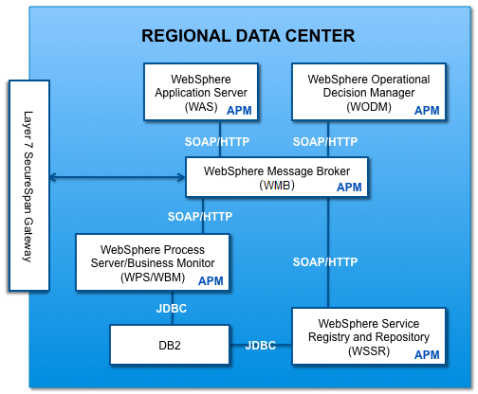

Figure 29 – Overall Regional Software Component Architecture[31]

##### Hardware Interfaces

Figure 29 below shows the cluster deployment topology for regional deployments. Each WebSphere product will be clustered. WSRR, ODM, WPS, and WAS will be clustered initially in dual redundant configuration. IB will be vertically clustered with an initial deployment of four VMs in the vertical cluster. This vertical cluster will share storage to provide for reliable message delivery if one of the IB instances in the cluster fails.

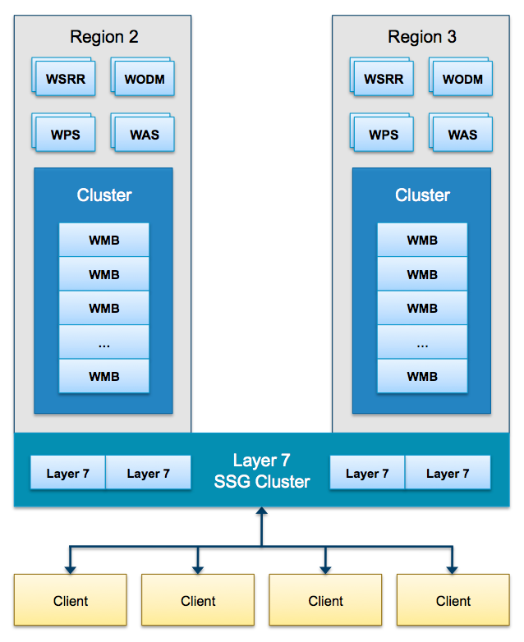

Figure 30 – Regional Clustering Approach[32]

IB/MQ will be clustered vertically. MQ clustering does not synchronize for redundancy. The design point for clustering is to provide continuous availability for services (i.e., immediate failover to the other member of the cluster), but there is still the risk of individual messages being “stranded” at the failing MQ/site while service is being restored. MQ handles this locally through the “multi-instance” queue manager that uses shared storage, but this is not intended for use between remote sites.

The regional CA API Gateways will be installed in an enterprise cluster. Each region will run an initial two instances with one database installed. An enterprise cluster requires only two database instances and these will be installed so that there is one in each region. These databases are synchronized so that when a policy is applied to any CA API Gateway instance, it will push the policy to all other CA API Gateway instances in the cluster. It also supports a unified certificate store through the cluster synchronization.

The SOA Suite environment consists of a Melbourne, FL (MLB)-based Contractor data center where all of the initial development, integration, and verification efforts will be completed prior to deployment. This data center will also serve as the primary site for baseline control. As the baseline matures, it will then be cycled to the VA DTE at AITC for development, integration, and pre-production testing of services integrated with the SOA Suite architecture.

After successful verification and validation, the baseline will be deployed to VA production sites at AITC and PITC. It is important to note that each one of these environments (MLB, DTE DEV, DTE INT, and DTE PERF) involve some aspects of development, integration, testing, and verification in order to provide a complete healthcare messaging system. It is critical that all of these environments are maintained at the same configuration baseline under change control. It is also critical that the as-built deployed software be re-provisioned back to the MLB environments during service development as well as at the end of successful service integration so that baseline integrity is maintained to reproduce and troubleshoot field problems.

Figure 30 shows the SOA Suite system flow, and each arrow represents a deployment.

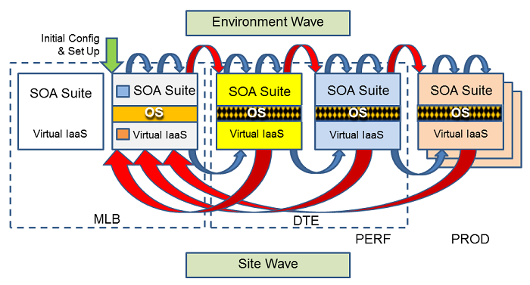

Figure 31 – SOA Suite System Flow[33]

##### Software Interfaces

Table 11 provides a list of the COTS products and their versions. These are in addition to the VA EO-provided infrastructure that includes the host VMWare, VM System Utilities, and VM Operating Systems[34]. The current version of the eMI SOI (as a whole) is v2.2.0.0. All packages (and their versions) in Table 11 are TRM-approved.

Table 11 – COTS Product Versions

| Supplier | COTS Product Description | Name on TRM | TRM Approved Version | TRM Decision Date | Acronym | Previous Release | v2.2.0.0 |
| --- | --- | --- | --- | --- | --- | --- | --- |
| IBM | WebSphere Process Server | Integrated into IBM Business Process Manager:  IBM Business Process Manager | 8.5 | 10/31/2014 | WPS | 8.0.1.1 | 8.5.6 |
| IBM | IBM Integration Bus | IBM Integration Bus | 9.0.x | 9/30/2014 | IIB | -- | 9.0.0.2 |
| IBM | Healthcare Connectivity Pack for IIB | IBM Integration Bus Healthcare Pack | 3.0 | 9/30/2014 | HCP | -- | 3.0 |
| IBM | WebSphere Transformation Extender (included in WMB03 and 04) | WebSphere Transformation Extender | 8.4.1.2 | 9/30/2014 | WTX | 8.4.1 | 8.4.1.2 |
| IBM | WebSphere Message Queue | IBM MQ | 8.0 | 9/30/2014 | WMQ | 7.5.0.2 | 8.0.0.2 |
| IBM | WebSphere Data Base DB2 Server | DB2 | 10.5 | 6/30/2015 | DB2 | 9.7.8 | 10.5.5 |
| IBM | WebSphere Business Monitor or “Business Process Monitor” | IBM Business Monitor | 8.5.5 | 9/30/2014 | WBM | 8.0.1.1 | 8.5.6 |
| IBM | WebSphere Operational Decision Management | WebSphere Decision Center  WebSphere Decision Server | 8.5  8.5 | 2/28/2014  2/28/2014 | WODM | 8.0.0.5 | 8.7.0 |
| IBM | WebSphere Service Registry and Repository | WebSphere Service Registry and Repository | 8.5 | 9/30/2014 | WSRR | 8.0.0.2 | 8.5.5 |
| Mirth | Connect (with Postgres) | Mirth Connect | 3.0.x | 6/30/2014 | n/a | 2.2.2 | No longer needed |
| Computer Associates | Layer 7 SecureSpan Gateway (uses MySQL 5.5.4.3); nka “CA Layer 7 API Gateway” | Layer7 SecureSpan Gateway (SSG) | 8.0 | 10/31/2014 | L7 | 7.1 | 8.3 |
| Red Hat | Network Attached Storage NFS for Linux | **Network Attached Storage NFS for Linux** is built into Red Hat Enterprise Linux | 7.x | 5/31/2015 | NAS | v4.4.2.3-22.el5 | v4.4.2.3-22.el5 |
| IBM | HTTP Server | IBM HTTP Server | 8.5.x | 8/27/2014 | HTTP | 8.0.0.6 | 8.5.5.5 |
| IBM | Deployment Manager/WebSphere Application Server | WebSphere Application Server  WebSphere Application Server Network Deployment | 8.5.5.x  8.5.5 | 3/16/2015  2/28/2015 | WDM /WAS | 8.0.1.1 | 8.5.5.5 |
| Oracle | Java Runtime Environment | JRE-IBM | 7 | 10/29/2013 | JRE | v7 (Layer 7) and  v6 (APM) | V7u80 and v8u45 are used |
| Puppetlabs | Puppet Enterprise | Puppet Enterprise | 3.8.x | 6/30/2015 | n/a |  | 3.7.2 |
| Red Hat | Linux OS | Red Hat Enterprise Linux | 7.x | 5/31/2015 | RHEL |  | 6.6 |
| IBM | IBM License Metric Tool | IBM License Metric Tool | 9.0 | 8/14/2014 | ILMT |  | 9.2.0 |
| F5 Networks | Load Balancer (GFE, test tool – will not be in VDD) | F5 Big IP Global Traffic Manager | 11.4 | 8/31/2014 | LB |  | 8 |

The SOA Suite system was designed and integrated to provide a repeatable and configurable deployment using OVA images When developing component configurations, it is best practice to essentially destroy and rebuild the configuration from scratch in a scripted or automated manner. This methodology ensures that changes are not only introduced into the baseline, but that they do not have any unforeseen side effects that could affect components that worked previously. Imaging deployment and consistent configuration baselines enhance the security posture of the system.

When the EMI Integration team creates scripts/components, it considers how the pieces would be put together into a cohesive unit. With an array of modular components and scripts to tie them together, it becomes difficult to understand system dependencies and how to assemble the components to make a system[35].

In order for verification to be effective and efficient, there must be 100% repeatability. When problems arise, they should be reproducible within the development environment. Lack of automation significantly increases the risk of manually introduced errors.

Artifacts that were created during the development process are collected, organized, and eventually deployed to the target virtual environments. The EMI Deployment team is generally focused on several components, as shown in Figure 31.

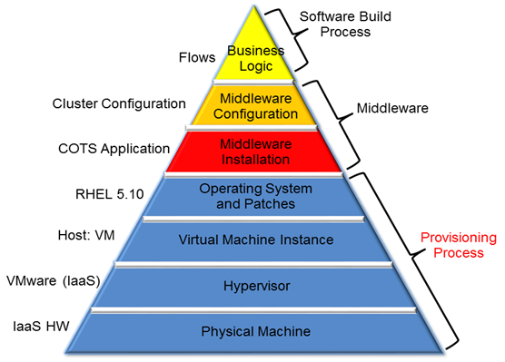

Figure 32 – Deployment Team Focus[36]

The eMI team is using Enterprise Operations’(EO) Puppet Enterprise for deployment and CM automation for the middleware and software build process layers. This selection is in support of EO TRM listed products, and fits in with the approach they use to rebuild VMs in case of a disaster. Puppet Enterprise is a TRM-under-constraint-approved package. eMI is using it as part of the EO/AITC Platform as a Service (PaaS). Puppet is installed in the VA Cloud infrastructure (AITC) and is under the EO’s enterprise licensing scheme. Changes to the packages status, versions, and TRM-compliance are controlled by the EO plans and they will affect and be reflected promptly on the eMI roster of tools[37].

Once the system has been deployed to the field, the sustainment effort begins. Patches, COTS bug resolution, and configuration changes will still need to be deployed to the field over time. The challenge is that a fix must now be deployed into multiple actively used environments. The deployment process establishes whether these fixes can occur as a “hot” upgrade or whether down time must occur. An automated deployment process will minimize down time of production systems and facilitate fall back procedures.

##### Communications Interfaces

The SOA Suite components use a number of ports and protocols for message exchange, administration and monitoring. These ports and protocols are listed in Table 12.

Table 12 – Ports and Protocols

| Application | Application Port Purpose | Ports | Protocols/  Services Used | Inbound | Outbound |
| --- | --- | --- | --- | --- | --- |
| WODM | Admin console secure port | 9043 | HTTPS | Y | N |
| WODM | Admin console port | 9060 | HTTP | Y | N |
| WODM | HTTP Transport | 9080 | HTTP | Y | N |
| WODM | HTTPS Transport port | 9443 | HTTPS | Y | N |
| WODM | Rules Execution Server | 9633 | HTTP | Y | N |
| WODM | Bootstrap address | 2809 | HTTPS | Y | N |
| WODM | SOAP Connector Address | 8880 | HTTP | Y | N |
| WSRR | Admin console secure port | 9043 | HTTPS | Y | N |
| WSRR | Admin console port | 9060 | HTTP | Y | N |
| WSRR | HTTP Transport | 9080 | HTTP | Y | N |
| WSRR | HTTP Transport port | 9443 | HTTPS | Y | N |
| WSRR | Bootstrap address | 2809 | HTTPS | Y | N |
| WSRR | SOAP Connector Address | 8880 | HTTP | Y | N |
| WPS | Admin console secure port | 9043 | HTTPS | Y | N |
| WPS | WebSphere Process Server Explorer | 9443 | HTTPS | Y | N |
| WPS | Admin console port | 9060 | HTTP | Y | N |
| WPS | HTTP Transport | 9080 | HTTP | Y | N |
| WPS | Bootstrap address | 2809 | HTTPS | Y | N |
| WPS | SOAP Connector Address | 8880 | HTTP | Y | N |
| WebSphere | Allows for 200 queue managers per machine | 2100 thru 2200 | MQ | Y | Y |
| WebSphere | Admin | 7080 | HTTP | N | N |
| WebSphere | Admin | 7083 | HTTPS | Y | N |
| WebSphere | CSIV2 SERVERAUTH | 9406 | SSL | Y | N |
| WebSphere | DCS Unicast address | 9353 |  | N | N |
| WebSphere | SAS SSL Serverauth | 9404 | SSL | N | N |
| WebSphere | SIB Endpoint Address | 7276 |  | N | N |
| WebSphere | SIB Endpoint Secure Address | 7286 |  | N | N |
| WebSphere | IPC Connector Address | 9633 |  | N | N |
| WebSphere | SIB MQ | 5558  5578 |  | N | N |
| WebSphere | SIP Default Host | 5060 |  | N | N |
| WebSphere | SIP Default Host Secure | 5061 |  | N | N |
| WebSphere | WC Adminhost | 9060 | HTTP | Y | N |
| WebSphere | WC Adminhost  secure | 9043 | HTTPS | Y | N |
| WebSphere | Default host | 9080 | HTTP | Y | N |
| WebSphere | Default host secure | 9443 | HTTPS | Y | N |
| WebSphere | ORB | 9100 | IIOP | Y | Y |
| WMB | Demo traffic | 7080 | HTTP | Y | N |
| WMB | HL7 | 2111 | HL7 MLLP | Y | Y |
| WMB | HL7 | 3111 | HL7 MLLP | Y | Y |
| WMB | MQ transport | 61100 | MQ over SSL | Y | Y |
| WMB | MQ transport | 61200 | MQ over SSL | Y | Y |
| DB2 | Internal database server to support WODM, WPS, and WSRR | 50000  50001  50010  50011  50012  50020  50021  50022 | ODBC,JDBC | Y | Y |
| Integration Bus | HL7 Messaging | 6661  6662 | HTTP | Y | Y |
| Integration Bus | HL7 Messaging | 6663 thru  6666 | HL7 MLLP | Y | Y |
| Integration Bus | Admin Console | 8843 | HTTPS | Y | N |
| Integration Bus | Postgres | 5432 | SQL | N | N |
| Integration Bus | Web Start | 8080 | HTTP | Y | N |
| Integration Bus | JMX Port | 1099 | JMX | Y | Y |
| Integration Bus | Secure File Transfer Protocol (SFTP) | 22 | SFTP | Y | Y |
| Integration Bus | Tunnel | 9000-9999 | SSL | Y | Y |
| Integration Bus | SupportNet | 443 | TCP | N | Y |
| Integration Bus | SupportNet | 1194 | UDP | N | Y |
| Integration Bus | Monitoring | 161  162 | SNMP | Y | Y |
| Integration Bus | Mail | 25 | SMTP | Y | Y |
| Layer 7 | Admin | 8080 | HTTP | Y | N |
| Layer 7 | Admin | 8443 | HTTPS | Y | N |
| Layer 7 | Database | 3306  3307 | JDBC | N | N |
| Layer 7 | Admin Requests (log viewer, etc.) | 2124 | TCP | Y | N |
| Layer 7 | Replay Protection Synch | 8777 | TCP | N | N |
| Layer 7 | Remote Management | 8765 | TCP | Y | Y |
| Layer 7 | HL7 traffic | 2111  3111  6664-6669 | MLLP | Y | Y |
| APM | Communication with Introscope Enterprise Manager MOM | 5001 | TCP | Y | Y |
| APM | Introscope WebView | 8080 | HTTP | Y | N |
| APM | Introscope WebView | 8081 | HTTP | Y | N |

##### Memory Constraints

N/A – Not an element of the eMI SOA Suite.

##### Memory Constraint

N/A – Not an element of the eMI SOA Suite.

##### Special Operations

* **Manual Configuration.** Currently, the EMI Development and Deployment teams must perform an abundance of manual, repetitive activities to complete a successful deployment. The human factor all but guarantees that configuration variations will be introduced. There is no automated tool in place to deploy, track, and control each environment’s configuration. Configuration of a typical SOA Suite region requires an average of 120 hours with a team able to apply lessons learned for the different COTS products.
* **Deployment Method.** For every major release, deployment into production is executed using OVA files exported from the approved baseline. This deployment methodology has been proven to be time consuming and is not preferred by the VA IaaS provider. Deploying the SOA Suite stack to a new regional site from OVA images requires about 40 hours before the VMs are ready to be configured. Configuration of a typical SOA Suite region requires an additional 100 to 120 hours. Future releases are impacted by the challenge of selecting a different deployment methodology.
* **Maintenance Releases.** For minor releases and patches, the current deployment plan entails the manual transfer of large files with manual file copy and move operations, supplemented by scripting where practical. Failback procedures for deployment of updates, patches or maintenance releases are based on documented steps to recover from VM snapshots or backups. In addition to being time consuming, the maintenance and failback processes are prone to human error. Deployments and failback procedures increase the risk of extended down time to production systems.
* **Monitoring the Configuration.** Once a release is deployed, there is no capability to actively monitor configuration changes. Configuration changes made at the OS level are performed by the IaaS provider with coordination with the SOA Suite program. In the event of a change rendering a VM non-operational, redeployment is the only available option to ensure a baseline is in place.

#### Product Features

More information on eMI’s SOI components can be found at the following links.

* [WebSphere MQ Version 7.0.1 documentation](http://publib.boulder.ibm.com/infocenter/wmqv7/v7r0/index.jsp)
* [IBM - High availability](http://pic.dhe.ibm.com/infocenter/iseries/v7r1m0/index.jsp?topic=%2Frzahg%2Frzahgha.htm)
* [IBM WebSphere Message Broker Information Center](http://www-01.ibm.com/support/knowledgecenter/SSKM8N_7.0.0/mapfiles/help_home_msgbroker.html)
* [IB requirements](http://www-306.ibm.com/software/integration/wbimessagebroker/requirements/)
* [MQ documentation library](http://www-306.ibm.com/software/integration/wmq/library/)
* [IBM Integration Bus design and deployment](http://www-03.ibm.com/software/products/en/ibm-integration-bus)

#### User Characteristics

The users on the eMI functionality could be classified into three categories even though, strictly speaking, only the first category constitutes the profile of a typical user.

1. eMI’s hosted applications’ users. These users are the users of the applications whose SOA-based services are registered in the WSRR and their transactional usage and monitoring is exercised via the eMI ESB. These users should not notice any changes and they should not feel any effects, as the messaging infrastructure should be transparent to them.
2. eMI’s hosted applications’ developers. These users are expected to be SOA-knowledge. Their responsibilities include the collaboration with the eMI’s integration team to realize the smooth transition of an application’s onto eMI.
3. eMI’s integration and administration teams. These users are all skilled in the SOA tools administration and SOA integration aspects of eMI. They are part of the eMI team and since their responsibility is to maintain eMI in good operational status. Their skills and knowledge are well specified and part of the existing eMI stuffing requirements.

#### Dependencies and Constraints

This section describes the assumptions and constraints that influenced the design of the system.

* Enterprise Operations (EO) will provide global load balancers at the RDC sites
* EO is responsible for health and maintenance of all VMs and the associated OS on each VM at every VA eMI site (Enterprise and RDCs)
* Operations and health of the applications that make up eMI are the responsibility of the O&M Team for eMI
* Integration of new services is supported by the eMI Integration team
* eMI consumes from VA policies, procedures, and solutions:
  + Business Process Modeling via Rational tool suites
  + Approved Business Rules built in IBM Rules Builder, and tested by functional experts
  + Configuration Automation via Puppet
  + Network Analysis via CA Spectrum
  + Authentication and Accreditation policy and systems
  + IAM policy and systems
  + CA policy and systems
  + Message patterns related to web services
  + RBAC schema and relations between systems
  + Security enforcement and monitoring
  + Monitoring
* eMI delivers for application and end user reuse
  + Business process monitoring for any Business Process Model implemented in IBM BPM
  + Business Rules Execution metrics for Business Rules implemented in IBM BPM
  + Governance and utilization metrics based upon implemented SLAs
  + Access to eMI dashboards in the VA monitoring solution, or to individual data measures captured herein
  + Response to issues in integrated services based upon eMI definitions of incident response, and defined in the SLD
  + Access to log reports and alerts via ELK
  + Discoverable web services via WSRR
  + Message routing and transformation in IIB
  + XML Proxy, policy enforcement, and security enforcement of previous VA policies in CA API Management (formerly Layer 7)
* Government will provide the CA API Management Suite and Application Performance Management (APM) Agent licenses
* Trust, identity, and encryption verification for external sources will be extended so that all traffic running thru eMI will be encrypted, and include information to support audit and attribution to a requestor and known system(s)
* Data non-repudiation methods are the responsibility of the producer of a service. The producer should design patterns under VA policy, and should conform with the consumer needs for data transformation and translation at eMI
* Application owners will be responsible for providing their own VA complaint cloud or physical infrastructure
* Legacy systems will deliver modern web services for VA reuse, using either a local encapsulation method or by modernizing their APIs

##### Design Assumptions

The key assumptions for the SOA Suite implementation are:

* Network infrastructure will be provided as GFE, owned and maintained by the government, and used to host eMI
* Data centers [e.g., operating system (OS) infrastructure] will be provided as GFE
* The Government shall provide access to facilities (network, physical, etc.) in a timely fashion to address build, monitoring, break-fix, analysis and maintenance needs
* Authorization to Operate (ATO) will be granted in a timely manner by VA
* eMI will enforce security policies but not define or dictate them
* Local facilities will prefer to communicate with their default region, per the VA regionalization plan for VistA and the four current co-location facilities

##### Design Constraints

The two design constraints that have the most influence over the eMI architecture are performance and high availability. The specific requirements driving the constraints are outlined in the PWS, detailed in the RTM, and validated in SID 028 Demonstration Plan. eMI must achieve the government’s requirement thresholds for message throughput and availability outlined in the PWS and detailed in the RTM.

The second defining constraint is the availability of infrastructure in the VA to house a robust environment to support business needs and throughput. A distributed architecture with global load balancing provides the most protections for a highly available system. The VA has identified that their best solution is to co-operated facilities in Austin, TX and Philadelphia, PA. These are VMWare hosted “cloud” environments with all physical and virtual assets controlled and maintained by the VA Enterprise Operations (EO) team. They also have a hosted F5 BIG-IP product for global load balancing. In trade-off, access and design of VMs in this center are tightly controlled, and take a considerable amount of time to provision, sometimes exceeding many months. This is a lights-out center, and access is made via remote systems such a Citrix Access Gateways (CAG) and via direct secured access from GFE laptops under VA security controls. All VMs are controlled for access, following EO policy regarding use of login identity and rights.

The use of a federated infrastructure to help balance some of the load is another constraint included for consideration. EO has developed specifically for eMI’s needs environments co-located with the VA VistA regionalization facilities, to allow the “local” approach for the eMI design. VA has provided IBM licenses to expand the footprint using the IIB Express functionality to extend message brokering and transformation. These local sites are envisioned to help with specific legacy system roll-off, such as VIE, and for “local” only operations that would make better sense to house away from the larger enterprise, because these operations would not be shared widely or made available for others to consume.

These constraints drove a redundant clustered architecture throughout the enterprise and regional locations. The regions can be federated to the enterprise, and the enterprise instances are federated to each other. Growth in any region or enterprise instance is scalar, meaning as demand grows, more of the needed applications can be clustered in to hand the load. The current design at the application level meets and exceeds both the threshold and objectives set by the requirements. The system is designed to be virtualized and to operate in VA data center “clouds” using hypervisor technologies and clustering in the software component and database layers of the middleware.

The following design constraints are applied to the development of the virtualized computing infrastructure.

* Support for open standards.
* Ability to meet performance thresholds specified for the SOA Suite.
* Components in compliance with VA TRM.
* Servers and software components must run on x86-based chip sets.
* COTS software must run on Red Hat Enterprise Linux (RHEL) OS v5.10 at a minimum. (Currently running on 6.x)
* Servers shall be virtualized; the best-in-class VMware VSphere v4.1 has been chosen to leverage the VCenter, VMotion, and clustering capabilities.
* Support 99.999% software application-layer availability for Production Environment. This applies to software applications that support real-time message processing and does not include elective maintenance downtime. At the enterprise level the software applications are deployed at both AITC and PITC for site-level redundancy. Software applications at the RDC are deployed such that each RDC has an assigned backup RDC for site-level redundancy. Overall Production Environment availability is a product of Private Cloud Platform as a Service, System Monitoring and software application-layer availability.
* Support highly scalable architecture where resources can expand and contract as demand warrants.

Additional constraints are:

* Current Information Assurance (IA) boundaries (increase latency and complexity, decrease bandwidth)
* Lead time for procurement of hardware [VA virtual machines (VMs) will be used but still require procurement cycle time] makes it difficult to be Agile (six months lead time)
* Availability of OS infrastructure
* Availability of network infrastructure

##### Design Trade-Offs

A significant design trade-off for this architecture is the selection of different vendors and products for enterprise v. regions. The EMI Team weighed the option of using a single product across enterprise and region implementations, understanding that having different products can introduce risk in the form of additional support, integration, training, and maintenance efforts. While the EMI Team is able to deploy a single product at all levels, if the client prefers at the government’s direction, then the Team has determined the risks were more than offset by the cost benefits of a multi-vendor approach. By deploying different vendors’ products, the Team is able to provide the government the required capability for a better value while providing adherence to open standards and preventing vendor lock-in. Where WebSphere and CA API Management (Layer 7) must interoperate, they do so using common standards and open interfaces.

The following is a brief benefits analysis of deploying the IBM stack at the local sites via WebSphere Message Express/Integration Bus.

The benefits of WebSphere messaging are:

* One stack from enterprise to regional implementation
* Ability to handle higher volumes of message traffic with fewer VM instances
* More seamless integration with the Regional WebSphere Integration Bus (IB) and Message Queue (MQ) engines
* Consistent 99.99% (“four nines”) and 99.999% (“five nines”) uptime policy
* Reduced development and test times due to fewer deployment profiles

### Specific Requirements

#### Database Repository

N/A – Not an element of eMI.

#### System Features

##### Significant Functional Requirements

The significant functional requirements related to the RDC design represent a sub-set of all requirements as specified in SID 031 RTM and include the following.

* INT03.01 - The SOA Suite shall provide support for HL7 version 2.x and 3.0 natively.
* INT03.01a - SOA Suite shall support HL7 version 2.2, 2.4, and 2.5.1 message formats via Minimum Lower Level Protocol (MLLP).
* MED01.18 - The SOA Suite shall support the MQ interface.
* MSG02.5 - The SOA Suite shall support synchronous message routing.
* Migration of DoD Data Exchange Service capabilities and services to the VA eMI

The forthcoming clinical apps (Laboratory, Pharmacy, and Immunizations) provide the context for the near-term eMI utilization patterns. These will give real requirements for such areas as:

* Message flows and type
* Capacity and scaling
* Error handling

eMI is a fully functioning messaging platform that supports a variety of end user needs and technical message types. The intent of having a functioning web service platform is to drive the use of modern standards and implementations in REST, JMS, and SOAP. Nonetheless, the stack can support an expansive list of message formats. Here are a few of the most common message formats and protocols that are currently in the VA stack (but this is not an exhaustive list):

* HTTP
* HTTPS
* MLLP HL7
* SFTP
* WebSphere MQ
* JMS 1.1
* SOAP
* REST
* TCP/IP
* Self-defined formats

More information can be found in [this IBM document](https://www-01.ibm.com/support/knowledgecenter/SSMKHH_9.0.0/com.ibm.etools.mft.doc/bb43020_.htm)

Regarding VII, there is no requirement for data transformation and translation for this phase of the project. The data transmitted to and from DMIX should simply be “proxied” by eMI. There is no requirement for protocol transformation for this phase of the project. All DMIX Data services with externally-facing interfaces shall be exposed to the Enterprise via eMI (WSRR)

##### Functional Workload/Performance Requirements

The SOA Suite shall, at the enterprise level, meet or exceed the SOA Suite Performance Requirements included in the July 2014 PWS Attachment 1, accessible via the link to the VA eMI SharePoint site provided below.

<http://vaww.oed.portal.va.gov/pm/iehr/vista_evolution/SOA/Harris%20Deliverables/MISC%20(non-CDRL)/Attachment_A-PWS_CH5-Planning_Version_2014-07-23.docx>

These Military Health System/VA Enterprise throughput metrics for continental United States include Extensible Markup Language (XML) and HL7 message type average packet size, latency, and throughput values. Reference the SOA Suite performance requirements included in the July 2014 PWS Attachment 1 for more detail.

Additionally, the SOA Suite supports the 15 VIE applications per the Application Design Document for Laboratory Data Sharing and Interoperability (LDSI) published and approved in February 2015. The performance requirements for specific applications are still being determined as part of the discovery process for each application, which may result in updated or additional application specific design documentation. In general, they will include these requirement elements.

* Message throughput performance for each VIE application
  + For example, each VIE application at the local site should perform greater than the current VIE application with actual message throughput (approximately 50+ messages per second) measured on a site-by-site basis
* Error notification for multiple error scenarios
* Provide alerts to eMI and subscribing customer administrators in the event of message or business process failure
* VIE application monitoring for health and heartbeat
* When the receiving systems goes down, eMI should be executing persistent retries to send the messages to guarantee message delivery
  + For example, guaranteed message delivery uses message retries until delivery is confirmed

The final design needs for the RDCs to be implemented in six sites within the VA are below. The options included a variety of load-balancing, failover, hub and spoke, and encryption needs. Requirements include the following.

* Deployment will be to the regional sites of Brooklyn, Denver, Philadelphia, Sacramento, St. Louis, and Warner Robins.
* Traffic must be encrypted in flight between the VistA sources and the receiving end points getting VIE related data.
  + Exception: Outpatient Pharmacy Automated Interface data will remain in region and will not be held to this requirement.
* VistA end points do not encrypt, so encryption will need to start at the first eMI interaction.
* The target endpoints may expect traffic unencrypted, and if so, a message will be sent from the last eMI point in the clear.
* The design must be able to meet future needs and current VIE needs.
* Policy enforcement will be done at the RDCs.
  + Exception: VIE has no policies to enforce.
* Load balancing is essential within the RDC.
* Domain Name System (DNS) will be used to support failover needs, as VistA can support Uniform Resource Locators (URLs).
  + NOTE: VistA will “bind” to an Internet Protocol (IP) from DNS until that IP fails.
* As the environment needs to be scalable, deployment will start with sufficient components to satisfy VIE and add future capacity as needed. Fail-over patterns are shown in Table 13.

Table 13 – Fail-Over Pattern

| Region | Primary Site | Backup Site |
| --- | --- | --- |
| 1 | Denver | Sacramento |
| 2 | St. Louis | Warner Robins |
| 3 | Warner Robins | St. Louis |
| 4 | Brooklyn | Philadelphia |

* + It is assumed that the purpose of this is to assign VistA instances inside these regions to fail to specific data centers and that this will guide DNS strategy and routing table deployment for VIE only.
* Per the government on 12/16/2014, two load balancers, provided as GFE, will be implemented per site.

Given the above, the RDC configuration will be as depicted in Figure 32.



Figure 33 – General Design for RDC Instance (Six VMs per Site)[38]

Regarding the VII effort, where processing time is under control of the eMI team, the integration solution will be designed so processing times are likely to remain consistent with current averages. Actual eMI performance requirements for portions of the system under control of the eMI team will be captured within the eMI Service Level Agreement (SLA).

At full deployment, there would be approximately 330,000 requests per day. The initial integration will have an initial workload of approximately 1000 requests per day. The expected number of requests at peak time is eight requests per second and would it be evenly spread. At present, around 100 KB of data are provided by DoD as part of a response.

##### Operational Requirements

The significant operational requirements related to the RDC design represent a sub-set of all requirements as specified in [SOA SID 031 RTM](http://vaww.oed.portal.va.gov/pm/iehr/vista_evolution/SOA/Harris%20Deliverables/Forms/AllItems.aspx?RootFolder=%2Fpm%2Fiehr%2Fvista%5Fevolution%2FSOA%2FHarris%20Deliverables%2FSID%20031%20%2D%20Requirements%20Traceability%20Matrix%20%28RTM%29&FolderCTID=0x012000EF462204F467BF48A3E4F3B191209E2C&View=%7bF648AE20-2F7D-4CE5-A735-335935507C9B%7d) and include the following.

* AVA01.3 - The SOA Suite shall support running in a virtualized environment
* DEP02.2.9 - The SOA Suite shall provide support remote management through a console connection on the hosting system.

Each deployed system will adhere to VA RDC standards for systems operation, including:

* Daily monitoring of system resources
* Physical environment stability (i.e., room temperature, electrical supply)
* System and data backup and recovery
* System software updates and patches
* Security: physical and networking
* Support for disaster recovery processes and procedures
* System shall maintain the Audit Logs for 30 days.
* System shall generate reports that provide a summary of transactions per day as well as any errors found.

##### Technical Requirements

To facilitate data sharing between VA and DoD and to deliver an iEHR, the following capabilities are used as feature categories for the full set of Enterprise SOA Suite requirements. Some categories have modifications to accommodate Regional site implementation.

* Messaging
* Orchestration
* Mediation
* Process Monitoring
* Performance Monitoring
* Service Registry/Discovery
* Rules Engine
* Choreography
* Data/Messaging Transforms
* Protocol Conversions
* Quality of Service
* Security
* Business Process Management
* Business Activity Monitoring
* Governance
* Multi-pass processing of the response

These capabilities enable the transfer of data through service calls and message management. The capabilities planned for utilization within the VIE Migration effort are primarily those of the basic VIE message transport protocols which are a small sub-set of the full capabilities used to deliver an iEHR. The SOA Suite will enable common SOA services to include, but not be limited to, composite clinical application services of the iEHR, health services, and administrative services. These capabilities are currently described in the HL7 EHR-S Functional Model and informed by the VA/DoD integrated Business Reference Model.

Many core infrastructure services need to precede the core business services because the business services will need to draw from the capabilities provided by the infrastructure services. Anticipation for infrastructure services can be identified by the needs of the business services. VA and DoD have agreed to focus on information principles including data standardization, terminology standardization, and data center consolidation.

An additional objective of acquiring the SOA Suite is to provide a foundation to support installation and configuration, operations, maintenance, and support for the reliable, secure delivery of enterprise common services to subscribers within a SOA framework. The objective of implementing a SOA Suite is to enable the following.

* Speed, application development and integration, and reduce time-to-market
* Increase application integration, interoperability, and data sharing
* Improve clinical workflow, optimize business processes, and provide enhanced Clinical Decision Support
* Provide semantic interoperability services to support a common syntax and terminology between the VA enterprise and between external partners
* Provide a foundation for SOA services that will sustain VA application performance and availability requirements
* Ensure the security, integrity, availability, and confidentiality of all data and applications that employ the SOA Suite
* Support a logical SOA infrastructure

eMI acts as an HTTP Proxy act as a network buffer between the DoD Data Exchange Service and the internal eHMP instance. For Response Formatting except for aggregating all patient information into a single JSON message, no additional transformation will be required (e.g. renaming/reordering JSON tags, etc.) Rest Services interfaces shall be used for delivering messages between eMI and both DoD Data Exchange Service and eHMP. Multi-pass processing of the response will be handled within eMI. Rest Services supports the asynchronous delivery of document metadata/data (two-pass) or document records (one-pass) for all data types.

##### Security and Privacy Requirements

In support of system operations, which will provide services to VA healthcare providers as well as potentially other organizations, the SOA Suite ESB will support the long-term intent of the iEHR and, as such, must meet VA’s security and privacy requirements. This section describes the technical, administrative, and procedural IA program and policies that govern the SOA Suite ESB and identifies all specific IA requirements and objectives, such as requirements for data handling or dissemination, system redundancy, and backup or emergency response. This document also references the security safeguards associated with external system interfaces and/or remote access solutions that are considered an integral part of the SOA Suite ESB.

The SOA Suite ESB includes all hardware and software components that comprise, where applicable, the VA accreditation boundary. It also includes security mechanisms for hardware, firmware, and software, all of which are involved in the successful operation of the SOA Suite ESB. These safeguards are used to implement and enforce the applicable agency’s security policy.

All data in transit is sent encoded (using a base-64 algorithm) via secure protocols over port 443. All usernames and passwords shall be encrypted using a VA approved utility such as JCryptor utility, which meets Federal Information Processing Standards (FIPS) 140-2 Requirements. Passwords are encrypted using FIPS-140 compliant algorithms such as 128 bit AES. Security requirements of the system defining its needed ability to safeguard data against loss or exposure, and to resist disruption by outside partners. In order to be able to make the Restful Service call a client certificate needs to be installed.

In cooperation with the Virtual Lifetime Electronic Record (VLER) ISO for VA certification, the SOA Suite ESB team will provide information to the ISO to assist in documenting the requirements of this system under the accreditation boundary of the iEHR, including providing documentation elements of the VA System Security Plan, Risk Assessment, Configuration Management Plan, Contingency Operations Plan, Privacy Impact Assessment, and other relevant documents.

Based on instructions from the VA ISO and Information Assurance Management, the SOA Suite ESB must provide documentation to meet the security requirements described in Table 14.

Table 14 – Security Requirements

| ID | Requirement(s) |
| --- | --- |
| VA Handbook 6500 | Information Security Program |
| VA Handbook 6500.3 | Certification and Accreditation of VA Information Systems |
| VA Handbook 6500.6 | Contract Security |
| VA Handbook 6502.4 | Privacy Act Reviews |
| NIST SP 800-18 | Guide for Developing Security Plans for Federal Information Systems, Revision 1 |
|  | Defense Information Systems Agency Field Security Operations |
|  | Security Technical Implementation Guides (STIGs) |

##### System Criticality and High Availability Requirements

Based on requirements stated in SID 032 System Requirement Specification/Business Requirements Document, the SOA Suite ESB must provide:

* The SOA Suite shall support VMware high availability clusters.
* The SOA Suite shall support availability of 99.99%. The SOA Suite software layer shall meet the annual availability level of 99.999% in production for operational and unplanned events. This also includes availability service levels provided by associated VA resources such as Networking and EO.
* The SOA Suite shall provide support for failover. This includes the SOA Suite supporting internal failures within local sites through failover to other virtualized servers at the same location and supporting internal failures at regional sites through failover to a designated backup region site. (Further documentation is referenced in Section 3.3)

##### Single Sign-On Requirement

The eMI SOA Suite is middleware software with no direct end user access. However, sign-on access is needed for system administrators. This access is accomplished via ‘Zero’ accounts that require Active Directory Lightweight Directory Access Protocol (LDAP) and eToken authorization after elevated VA security training, screening, and granting of permissions. The Linux systems in the SOA Suite use the VA LDAP single sign-on process.

##### Use of Enterprise Portals

N/A - The eMI SOA Suite is middleware software with no direct user access.

##### Special Device Requirements

No special devices are required.

##### Legacy System Retirement

The eMI SOA Suite is not directly replacing existing legacy applications.

Some applications, such as the Vitria Interface Engine, are having workflows migrated to eMI in support of their retirement. Critical for understand is:

* Workflows must be modernized to web services for any legacy application , in order to prevent security problems and other issues
* Migration of workflows off any existing architecture does not facilitate the existing architecture retirement. This is a governance decision that belongs to the VA Enterprise Architect, in light of their vision for the service oriented architecture approach for the VA

#### Design Element Tables

N/A – Not an element of eMI.

## Network Detailed Design

N/A –eMI utilizes the VA national network.

## Security and Privacy

### Security

The eMI SOA Suite Security controls have been implemented to comply with VA Handbook 6500. Table 15 describes at a high-level the key eMI security controls required for technical and operational implementation. For additional information related to full details of security, refer to Risk Vision ATO documentation.

Table 15 – Key eMI Security Controls

| Security Control | Implementation |
| --- | --- |
| Access Control, Identification, Authentication, and Authorization | *Note*: eMI assumes that all users will be authenticated to the One VA network through VA Identification and authentication processes. Access in to the services in eMI is still an architectural discussion that VA is working to build a comprehensive Identity and Access Management (IAM) solution to include token passing, etc.  Users will access the eMI through their respective services on VA network using IP/Port identification and connection to the eMI. Privileged users will access eMI through EO generated accounts using 9957 process, which will be specific to their function and are issued and monitored from EO. Messages will be encrypted using two-way SSL at the transport/session layer and via IP/Port identification at the network layer. |
| Auditing | All auditing to include infrastructure and application will be monitored by EO. |
| Media Protection, Transmission Confidentiality and Integrity | At this time, no electronic Protected Health Information (ePHI)/Personally Identifiable Information (PII) data will be stored within the eMI SOA Suite. Messages will be encrypted using two-way SSL at the transport/session layer and via IP/Port identification at the network layer. |
| Contingency planning /Disaster Recovery | EO is responsible for the Infrastructure and eMI is responsible for the Application. |
| Incident Response, Security Alerting | EO is responsible for Incident response and will notify eMI if there are any incidents. |
| Maintenance | EO is responsible for the maintenance of the eMI infrastructure. eMI is responsible for the application maintenance. |
| Physical and Environmental | EO is responsible for the Physical and environmental security controls. |
| Boundary Protection, network | EO is responsible for the boundary protection using Loadbalancers, firewalls, etc. |
| Cryptography | eMI has implemented two-way SSL which will be decrypted at the Layer 7 and IB. Certificates are provided by VA Public Key Infrastructure office and are compliant with VA Handbook 6500. |
| Patch Management, Vulnerability Assessments | EO is responsible for patch management of the infrastructure and eMI is responsible for the applications. Both eMI and EO CM processes are followed. Vulnerability scanning is the responsibility of the National Security Operations Center, and the remediations of findings are the responsibility of both EO and eMI. |

### Privacy

The eMI SOA Suite complies with all VA privacy policies. Table 16 describes at a high-level the key eMI privacy controls required for technical and operational implementation.

Table 16 – Key eMI Privacy Controls

| Privacy Control | Implementation |
| --- | --- |
| Governance and Privacy | A governance program has been implemented. Please refer to governance documentation for compliance. |
| Privacy Impact and Risk Assessment | As part of the ATO, a Privacy Impact Assessment and Risk Assessment have been performed for the eMI SOA Suite. |
| Privacy Enhanced System Design | The system design for eMI employs technologies and system capabilities that allow users to obtain PII/PHI through an ESB to eliminate additional copies of this type of data, automate collection, use, retention, and disclosure of PII. |
| Data Integrity | Data Integrity at this time is handled through two-way SSL, service IP/Port identification, and, in the future, will be ensured through an IAM solution. |
| Data Retention and Disposal | At this time no PHI/PII data is stored within the eMI system. If at any time there will be data stored, then encryption methods will be deployed according to VA Handbook 6500. |
| PII Used in Testing | No PII data is using in testing scenarios. |
| Incident Response | Incidents for PII are reported to the VA Privacy Officer. |

## Service Oriented Architecture/ESS Detailed Design

N/A – Not an element of eMI. eMI consumes this from integrating applications.

# External System Interface Design

## Interface Architecture

At the point of publishing this SDD, external interfaces to the VA are tightly controlled at the point of an interface gateway. These gateways appear internal to the VA, so little architecture configuration beyond what is already listed here is needed[39].

The following should be considered as future needs for external interface, understanding that this will require substantial policy definition and technical development outside of eMI to be successful.

### Recommendations

eMI recommends a three part architecture for messages to external partners. This same model should echo what a secure internal VA message should be designed to look like. The architecture should include:

* A true SAML architecture, with key identifiers that are consumable in VA and external trusted identity systems
* A PKI infrastructure, at an intermediate level, to fully encrypt message traffic to prevent middle attacks of either injection or observation
  + This infrastructure must be exposed to allow real-time verification of certificates
  + This infrastructure must be able to extend trust to external CAs, so that DoD and other customers can utilize their infrastructures
* A data non-repudiation segment from producer to consumer, instantiated at design time, so that systems receiving traffic can trust that the message has not been changed or injected with malicious code
  + This infrastructure must work both ways, as VA may be a producer or a consumer, requiring the need to validate against external certificates
  + The system must be designed such that, if a valid middle system such as eMI needs to transform or otherwise conduct business operations on a data segment, that the original non-repudiation and subsequent non-repudiation segments are preserved and available to the end systems

At this point, no current or future plans change the way that VA transacted business across domain boundaries. This presents issues for both security and for the HIPAA and HITECH requirements that VA must follow. eMI has a robust architecture for supporting web service communications, and will be able to handle any standards based approach used to create and extend trust and identity inside and outside the VA. These efforts are needed sooner rather than later to ensure a strong SOA approach for safe and effective service use and reuse.

## Interface Detailed Design

eMI will interface externally with the DoD’s DES. Figure 33, below, depicts the DSE-to-eMI architecture from DES’ point of view. Currently, the DMIX Data Exchange Service communicates directly with VistA Exchange and JLV via the BHIE Relay Service.



Figure 34. DMIX/eMI Interfaces[40]

The transition outlined in the Phase I goals in Section 0 (page 38) of this document will eliminate the need for the BHIE Relay Service and result in an eMI-DES connection as the sole interface between DoD and VA for sharing patient medical information. The DES currently interfaces with the following systems as shown in Figure xx below:

* **Clinical Data Repository (CDR)**: Central store for service member and beneficiary health care history
* **Composite Health Care System (CHCS)**: Provides for documentation of patient health information and history, order laboratory and radiology tests and services, retrieve test results, and order and prescribe medication
* **Essentris:** Allows documentation of inpatient care for service members and their beneficiaries
* **Theater Medical Data Store (TMDS)**: The TMDS System enables providers the capability to view and document an individual patient’s complete Theater electronic medical record
* **Defense Medical Surveillance System (DMSS)**:DMSS is a relational database operated by the Armed Forces Health Surveillance Center (AFHSC) to document military and medical experiences of service members throughout their careers. Connection of the DES to DMSS allows for the retrieval of Pre- and Post- Deployment Assessments without accessing the FHIE Repository via the BHIE Framework.
* **Health Artifact and Image Management System (HAIMS):** Provides data sharing capability for all types of artifacts and images, including radiographs, clinical photographs, electrocardiograph, waveforms, audio files, video, and scanned documents. In an upcoming release, the DMIX Data Exchange Service will provide a connection to HAIMS.

The following table shows the communication protocols and directions of all of the external systems which communicate with the BDA:

Table 17. DES’ External Protocols (Inbound)

|  |  |  |
| --- | --- | --- |
| External System | DES Version | Communication Protocol |
| JLV | V4 for Admissions, Appointments, Demographics, Encounters, Medications, Notes, Orders, Payers, Procedures, and Questionnaires; v2 for all others | REST SSL |
| TOL | V4 | REST SSL |
| VLER | V4 | REST SSL |

The following table shows the communication protocols and directions of all of the external systems with which the BDA communicates:

Table 18. DES External Protocols (Outbound)

|  |  |  |
| --- | --- | --- |
| External System (Directly Accessed) | External System (Indirectly Accessed) | Communication Protocol |
| AHLTA |  | POJO |
| SHARE |  | SOAP SSL |
| TMDS |  | SOAP SSL |
| XCA Data Services |  | SOAP SSL |
| XCA Data Services | FHIE Repository | JDBC |
| XCA Data Services | MPI | JDBC |
| XCA Data Services | VA VistALink | RPC |

# Human-Machine Interface

## Interface Design Rules

It is not anticipated that there will be any need for defining, designing, and developing any custom-made human machine interface for the eMI’s hosted applications’ users (see paragraph 6.2.1.3, page 66.) eMI’s subsystems are COTS products that are unchanged from their design. All documentation is available from the various vendors, if needed.

Regarding accessibility to eMI interfaces by people with disabilities, all tools in eMI SOI that are designed to be used by any of the users groups described in “User Characteristics,” (section 6.2.1.3, page 66,) offer user interfaces that are designed by their respective vendors to be compliant with the 508 stipulations.

## Inputs

N/A – eMI’s human-machine interface will require only input designed by the COTS vendors whose products are deployed within eMI.

## Outputs

N/A – eMI’s human-machine interface will produce output designed by the COTS vendors whose products are deployed within eMI.

## Navigation Hierarchy

A detailed set of guidelines for interfacing with the SOI’s Registry and Repository, an essential process in on-boarding SOA-based services onto the eMI environment is described in the [eMI Customer Intake Process](http://vaww.oed.portal.va.gov/communities/VAeMI/eMI%20WIKI/eMI%20New%20Customer%20Intake%20Process.aspx) section of the [eMI wiki](http://vaww.oed.portal.va.gov/communities/VAeMI/eMI%20WIKI/eMI%20IT.aspx).

The Registry and Repository (IBM’s WSRR) is integrated with the LDAP/Active Directory and all VA LAN users are granted the general user role to view and discover services and their associated metadata. Figure 34, below, depicts the Login Screen.

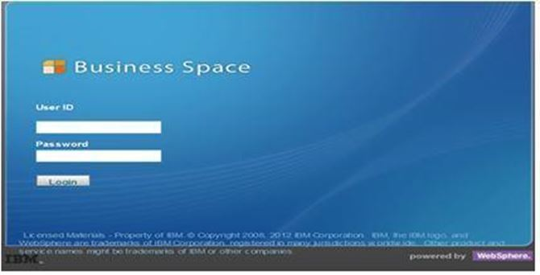

Figure 35. WSRR Login Screen

### Workspaces

After login, users will be provided with “workspaces” according to their respective role(s). The five workspaces are: Business, Developer, CoE, Operator and General User

### Navigation

Navigating to the various spaces can be done by selecting **Go to Spaces** on the top toolbar and then choosing which space to display.

Figure 35, below, shows the main screen in WSRR Business Space that can be used to navigate to various areas, search for services, perform actions etc.

* [Watch ListWidget](http://pic.dhe.ibm.com/infocenter/sr/v8r0/topic/com.ibm.sr.doc/cwsr_bs_watchlist.html): The watch list is a pre-configured version of the Service Registry Collection widget. You use it in the Business, Operations, Development, or SOA Governance spaces to view a list of items that might require your attention.
* [Service Registry Actions Widget](http://pic.dhe.ibm.com/infocenter/sr/v8r0/topic/com.ibm.sr.doc/cwsr_widget_serviceregistry_tasks.html): This widget is used to access key service registry tasks. Along with the Search widget, this widget is a main starting point for anything you want to do. It simply presents a list of clickable actions that can be configured.
* [Service Registry Chart Widget](http://pic.dhe.ibm.com/infocenter/sr/v8r0/topic/com.ibm.sr.doc/cwsr_widget_charts.html): This widget is used to display a collection of service registry items in the form of a pie chart, bar chart, or table.

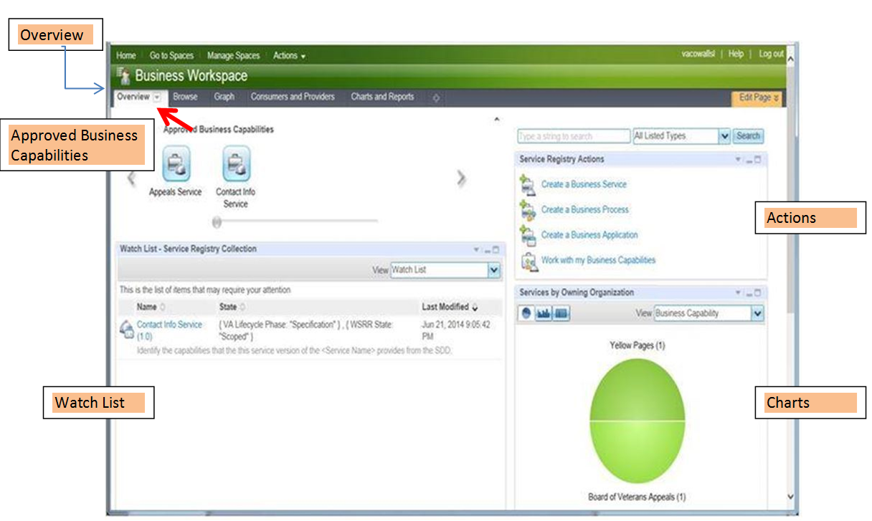

Figure 36. Typical Business Space Interface

* Service Registry Search Widgets: This widget is used to search for content in WSRR. Search results appear in the Service Registry Collection widget. The widget has a drop-down list of types, and you can choose which types appear in the list and the order in which they appear.
* Service Registry Collection Widget: This widget shows the results of the most recent search in a table. You can customize the formatting of the table per type or for multi-type search results. The details of the object are displayed in the Service Registry Detail widget.
* Service Registry Detail Widget: This widget displays the details of a selected object in WSRR. For each type, you can customize which details appear and how they are displayed.
* Service Registry Graphical Explorer Widget and Service Registry Navigator Widget: This widget displays registry content graphically.



Figure 37. Business Space Widget Examples

# Attachment A – Approval Signatures

This section is used to document the approval of the System Design Document. The review should be conducted face to face where signatures can be obtained ‘live’ during the review. If unable to conduct a face-to-face meeting then it should be held via LiveMeeting and concurrence captured during the meeting. The Scribe should add/es/name by each position cited. Example provided below.

The Business Sponsor and Project Manager are required to sign.

______________________________________________________________________________

Signed: Date:

< Business Sponsor >

______________________________________________________________________________

Signed: Date:

< Project Manager >

1. Additional Information
   1. Identification of Technology and Standards

Since eMI is an infrastructure system comprising of COTS packages, Table 11 on page 60 list all COTS packages and their versions used within eMI. In relation to VII, Table 19, below, lists the applicable standards.

Table 19. VII applicable standards

|  |  |  |
| --- | --- | --- |
| ID | Name | Description |
| Security Requirements | | |
| ENTR99 | Security | All VA security requirements will be adhered to. Based on Federal Information Processing Standard (FIPS) 199 and National Institute of Standards and Technology (NIST) SP 800-60, recommended Security Categorization is High. The Security Categorization will drive the initial set of minimal security controls required for the information system. Minimum security control requirements are addressed in NIST SP 800-53 and VA Handbook 6500, Appendix C. |
| Privacy Requirements | | |
| |  |  |  | | --- | --- | --- | | ENTR10 |  |  | |  |  |  | |  | | | |  |  |  | |  |  |  | | Privacy (Standard) | All VA Privacy requirements will be adhered to. Efforts that involve the collection and maintenance of individually identifiable information must be covered by a Privacy Act system of records notice. |
| ENTR95 | 508 Compliance (Standard) | All Section 508 requirements will be adhered to. Compliance with Section 508 will be determined by fully meeting the applicable requirements as set forth in the VHA Section 508 checklists (1194.21, 1194.22, 1194.24, 1194.31 and 1194.41) located at: (Link provided in Appendix C) or as otherwise specified. Checkpoints will be established to ensure that accessibility is incorporated from the earliest possible design or acquisition phase and successfully implemented throughout the project |
| Health Insurance Portability and Accountability Act (HIPAA) Requirements | | |
| ENTR2 | HIPAA | Computer systems shall track accounting of disclosure information when the system is accessed by a non-VA user. |
| ENTR3 | HIPAA | Computer systems shall allow for the correction or amendment of any piece of individually identifiable information. |
| ENTR78 | HIPAA | All efforts must be made to comply with the HIPAA Privacy Rule, which provides federal protections for personal health information held by covered entities and gives patients an array of rights with respect to that information. |
| Executive Order Requirements | | |
| ENTR7 | Executive Order (Standard) | Executive Order 13410-Promoting Quality and Efficient Health Care in Federal Government Administered or Sponsored Health Care Programs, Federal Register, Monday August 28, 2006 |
| Identity Management Requirements | | |
| ENTR8 | Identity Management (Standard) | All Enterprise Identity Management requirements will be adhered to. These requirements are applicable to any application that adds, updates, or performs lookups on persons. |
| Health Level Seven (HL7) Requirements | | |
| ENTR106 | Terminology Services (Standard) | Applications exchanging data summarizing a patient’s medical status shall conform to standards defined by the VHA-endorsed version of C 32 – Healthcare Information Technology Standards Panel (HITSP) Summary Documents Using Health Level Seven (HL7) Continuity of Care Document (CCD) Component. |

* 1. Constraining Policies, Directives, and Procedures

The updated SOA Suite will be processed through VA’s System Engineering and Design Review (SEDR) to ensure compliance with VA’s operational, security, and systems standards. This includes congruence with the VA Technical Reference Manual (TRM) of system and software standards.

* 1. Requirements Traceability Matrix

[SOA SID 031 RTM](http://vaww.oed.portal.va.gov/pm/iehr/vista_evolution/SOA/Harris%20Deliverables/Forms/AllItems.aspx?RootFolder=%2Fpm%2Fiehr%2Fvista%5Fevolution%2FSOA%2FHarris%20Deliverables%2FSID%20031%20%2D%20Requirements%20Traceability%20Matrix%20%28RTM%29&FolderCTID=0x012000EF462204F467BF48A3E4F3B191209E2C&View=%7bF648AE20-2F7D-4CE5-A735-335935507C9B%7d)

* 1. Packaging and Installation

N/A – eMI is an infrastructure system comprising of COTS packages.

* 1. Design Metrics

N/A – eMI is an infrastructure system that is hosting other applications’ SOA-based services.

1. BDA is the Bi-Directional Health Information Exchange (BHIE) DoD Adaptor
2. Each SOA-based application, of course would have its own user profiles, but those users would be unaware of the eMI’s role in their daily interaction with the applications that eMI would be hosting.
3. HARRIS Corp. as part of the initial VIE SDD produced this diagram. July, 2015.
4. Diagram created by HARRIS Corp. as part of the initial VIE SDD. July, 2015.
5. Diagram created by DoD as part of the initial VII planning meetings with VA. April, 2015.
6. Diagram created by DoD as part of the initial VII planning meetings with VA. April, 2015.
7. Diagram created by HARRIS Corp. as part of the initial VIE SDD. July, 2015.
8. Diagram created by HARRIS Corp. as part of the initial VIE SDD. July, 2015.
9. Diagram created by HARRIS Corp. as part of the initial VIE SDD. July, 2015.
10. When you start a multi-instance queue manager, start two instances using the STRMQM command with the option, STANDBY(*YES).
11. Diagram created by HARRIS Corp. as part of the initial VIE SDD. July, 2015.
12. Diagram created by HARRIS Corp. as part of the initial VIE SDD. July, 2015.
13. Diagram created by HARRIS Corp. as part of the initial VIE SDD. July, 2015.
14. As of August 2015.
15. Diagram created by HARRIS Corp. as part of the initial VIE SDD. July, 2015.
16. Diagram created by HARRIS Corp. as part of the initial VIE SDD. July, 2015.
17. Diagram created by HARRIS Corp. as part of the initial VIE SDD. July, 2015.
18. Diagram created by HARRIS Corp. as part of the initial VIE SDD. July, 2015.
19. For more details refer to the [BHIE Transition Plan (8/5/15)](http://vaww.oed.portal.va.gov/pm/iehr/vista_evolution/emivii/PMAS%20Documentation/System%20Design%20Document/DRAFT_Interoperability%20Enterprise%20Transition%20Plan_v3_08042015.docx)
20. eHMP documentation, August 2015.
21. DAS and VLER documentation. March, 2013.
22. CVIX and VistA Imaging Client documentation. August, 2013.
23. CVIX and VistA Imaging Client documentation. August, 2013.
24. CVIX and VistA Imaging Client documentation. August, 2013.
25. Diagram created by HARRIS Corp. as part of the initial VIE SDD. July, 2015.
26. Diagram created by HARRIS Corp. as part of the initial VIE SDD. July, 2015.
27. Diagram created by HARRIS Corp. as part of the initial VIE SDD. July, 2015.
28. eMI introductory materials for the VA’s application teams, December 2014.
29. eMI architecture documentation draft (aka Volume 4,) September 2014.
30. Currently the RDC System Design is considered universal for all RDCs. If the need arises for designs specific to particular RDCs, this document will be updated to reflect this need.
31. Diagram created by HARRIS Corp. as part of the initial VIE SDD. July, 2015.
32. Diagram created by HARRIS Corp. as part of the initial VIE SDD. July, 2015.
33. Diagram created by HARRIS Corp. as part of the initial VIE SDD. July, 2015.
34. The release version numbers provided in the Table 12 may not be the versions currently in effect. For a list of the most current COTS version numbers, refer to the latest version of [SID 049 Version Description Document](http://vaww.oed.portal.va.gov/pm/iehr/vista_evolution/SOA/Harris%20Deliverables/Forms/AllItems.aspx?RootFolder=%2Fpm%2Fiehr%2Fvista%5Fevolution%2FSOA%2FHarris%20Deliverables%2FSID%20049%20%2D%20Release%20Package&FolderCTID=0x012000EF462204F467BF48A3E4F3B191209E2C&View=%7bF648AE20-2F7D-4CE5-A735-335935507C9B%7d).
35. There are over 500 pages of installation, deployment, and configuration documentation. The difficulty of identifying system dependencies and planning an assembly of the components into an operational system should not be underestimated.
36. Diagram created by HARRIS Corp. as part of the initial VIE SDD. July, 2015.
37. Doug Smith, (EO Program Manager, AITC) ([Doug.Smith2@va.gov](mailto:Doug.Smith2@va.gov)) is the POC for this package.
38. Diagram created by HARRIS Corp. as part of the initial VIE SDD. July, 2015.
39. This is not a satisfactory answer when we consider the needs to fully secure, fully encrypt, and fully identify all message traffic in our domain, and balance that against increased demands to share information with DoD, Dept. of Treasury, and other external commercial entities to support the care of the Veteran.
40. DMIX External Interfaces Description, July 2015.